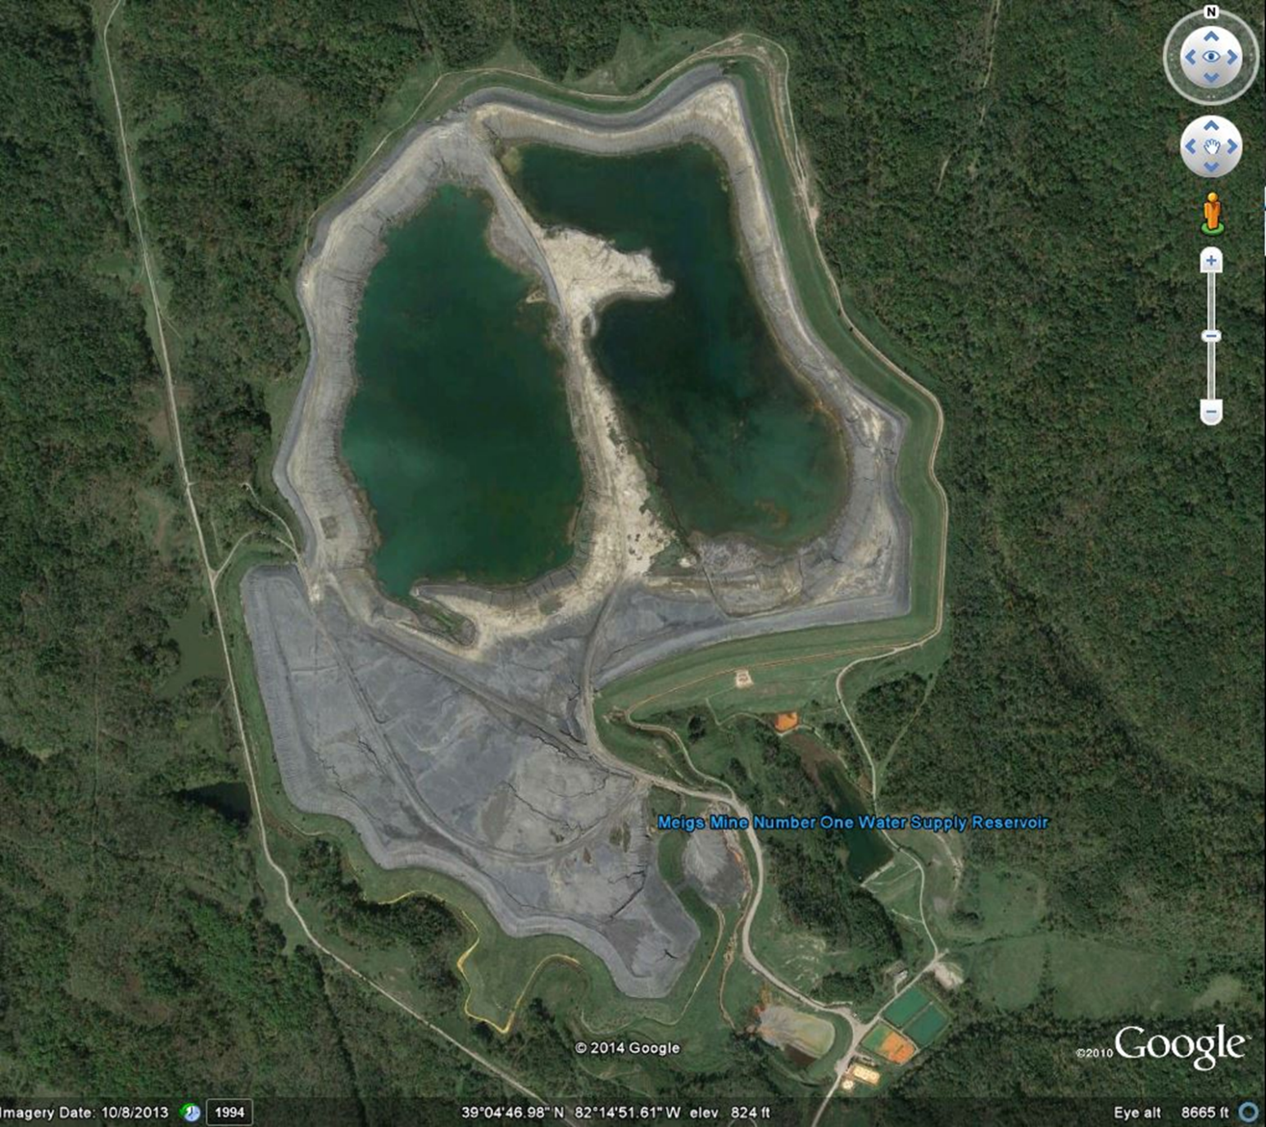
Southern Coal Company, Miegs Mine Number 1 (#31),1994 (USEPA)

