Title: Evaluating toxicity of sediments from the Little Calumet River, Indiana

Authors: Nile E. Kemble¹, Jeffery A. Steevens¹, Daniel W. Sparks²

¹USGS Columbia Environmental Research Center, Columbia MO,
²USFWS, Bloomington, Indiana Field Office, Bloomington, IN

ABSTRACT [not on the poster]

The eastern portion of the Little Calumet River is located in Porter County, Indiana and flows through Indiana Dunes National Park and before entering Lake Michigan. The purpose of this study was to evaluate sediments from the Little Calumet River for potential chemical contamination and associated aquatic toxicity. Ammonia and metals have been identified as potential contaminants of concern. We examined a total of 12 sites along the Little Calumet River that included three reference sites that were selected based on previous studies. Samples were collected by ponar, homogenized in the field, and subsampled for sediment chemistry, porewater analysis, and sediment toxicity tests. Toxicity tests were conducted following standard methods for acute and chronic sediment toxicity tests with freshwater invertebrates. Species tested included the amphipod Hyalella azteca (28-d exposure), the midge Chironomus dilutus (10-d exposure), and the mussel Lampsilis siliquoidea (fatmucket; 28-d exposure). These three species were selected because they have different exposure pathways and contaminant sensitivities. Toxicity test endpoints included survival, growth, and biomass. Mean control survival at the end of the exposures met test acceptability criteria for all three species. Results of these studies found significant reductions in survival and growth. Results of the bioassays will be compared to chemical concentrations in sediment and porewater as well as benthic survey data. This study will be used to inform resource managers on the potential biological effects of contaminants in this river system.

INTRODUCTION

- The eastern portion of the Little Calumet River (LCR) is located in Porter County, Indiana and flows through Indiana Dunes National Park before entering Lake Michigan.
- Ammonia and metals have been identified as potential contaminants of concern in this section of the river.
- The objective of the study was to evaluate sediment toxicity at 12 sites of the LCR (Figure 1), and to support the development of concentration response relationships between sediment chemistry and sediment toxicity.

METHODS
- Sediments were collected by petite ponar from 12 locations of the LCR which included three reference sites between June 28 to July 1, 2021 (reference sites 06 and 11 were porewater sites only).
- Sediments were subsampled in the field for sediment toxicity testing as well as the following chemical analyses: (1) total organic carbon; (2) metals, including simultaneously extracted metals and acid volatile sulfide; (3) organochlorine pesticides (OCs); (4) Pesticides; (5) Polycyclic aromatic hydrocarbons (PAHs); and (6) polychlorinated biphenyls (PCBs).
- Porewater was prepared by centrifugation and analyzed for metals, major ions, and water quality. Porewater metals were evaluated by determining the interstitial water benchmark units (USEPA, 2005).
- Laboratory bioassays were conducted in accordance with standard methods for conducting sediment or water toxicity tests with freshwater invertebrates including amphipods, midge, and mussels (Figure 2; ASTM 2021, USEPA 2000). Sediment from the Spring River in southwest Missouri (about 2% total organic carbon) was used as a laboratory control.
- Test duration for the exposures was 10 days for midge and 28 days for amphipods and mussels. Endpoints evaluated in the toxicity tests were survival, weight, and biomass. Biomass was calculated as a function of survival and weight.
- Feeding
  - Amphipod – Diet of ramped diatom and Tetramin (suspended flakes).
  - Midge – Diet of ramped Tetramin (particulate stock).
  - Mussels - 2 mL of an algal mixture automatically with each cycling of the diluter every 8 hours
- Survival, growth and biomass were evaluated by one-way analysis of variance (ANOVA) followed by Holm-Sidak’s or Dunn’s multiple comparison test. Test sediments were compared to the reference site (site 07).
- Metals, PAHs, OCs and PCBs were evaluated using Probable Effect Concentrations (MacDonald et al. 2000).
- Interstitial porewater metals were evaluated using interstitial water benchmark units (IWBU) and ΣSEM-AVS/ƒoc (USEPA 2005).

RESULTS AND CONCLUSIONS

Chemical Analysis
- Concentrations of metals, PAHs, PCBs, and OC pesticides alone were typically below concentrations that would be expected to be toxic to all three test organisms based on comparisons to sediment benchmarks. While some sites had elevated levels of contaminants, the concentrations of metals, PAHs, OCs and halogenated organics in sediments did not exceed the sum probable effect concentration quotient (PECQ) and would be classified as low risk (Figure 3).
- ΣSEM-AVS/f_{OC}, IWBU, and porewater ammonia are shown in Table 1. ΣSEM-AVS/ƒ_{OC} values were below 130 µmols/goc in 10 of 12 Little Calumet sediments. Sites 01 and 08 exceeded 130 µmols/g_{OC} and may result in adverse biological effects to aquatic species. Porewater unionized ammonia concentrations ranged from 0.007 mg/L (Site 05, SC) to 0.365 mg/L (Site 1, SD). Interstitial porewater metal concentrations were below concentrations expected to be toxic to test organisms based on IWBU analysis.
Sediment Toxicity Testing
- All exposures met ASTM (2021) and USEPA (2000) test acceptability criteria in all exposures for all three species.
- A total of 78% of the sediments (7 of 9 sites) were identified as toxic to at least one species as determined as a significant reduction relative to the reference site (Site 07) (Figures 4 and 5).
- Amphipods identified 56% of the sediment samples (5 of 9 sites), midge identified 11% (1 of 9) and mussels 22% (2 of 9) of the samples as toxic based on a significant reduction of at least one endpoint relative to the reference site.
- Amphipod biomass was the most responsive endpoint (44% of the sediments significantly reduced biomass relative to the reference site, Figure 5).
- Further analysis will be completed to establish concentration response relationships between test organisms and potential contaminants of concern.

REFERENCES
ASTM International. 2021. Standard test method for measuring the toxicity of sediment-associated contaminants with freshwater invertebrates (E1706-05 (2010)). Annual Book of ASTM Standards, Vol. 11.06. ASTM International, West Conshohocken, PA.
Canadian Council of Ministers of the Environment (CCME). 1999. Canadian sediment quality guidelines for the protection of aquatic life: Summary tables. In: Canadian environmental quality guidelines. 1999. Canadian Council of Ministers of the Environment, Winnipeg, Canada.
MacDonald DD, Ingersoll CG, Berger T. 2000. Development and evaluation of consensus-based sediment quality guidelines for freshwater ecosystems. Arch Environ Contam Toxicol 39:20–31.
Persaud, D.R., R. Jaagumagi, and A. Hayton. 1993. Guidelines for the protection and management of aquatic sediments in Ontario. Standards Development Branch. Ontario Ministry of Environment and Energy. Toronto, Canada.
U.S. Environmental Protection Agency. 2000. Methods for measuring the toxicity and bioaccumulation of sediment-associated contaminants with freshwater invertebrates, second edition: EPA 823-B-99-007, Duluth, MN and Washington, DC.
U.S. Environmental Protection Agency. 2005. Procedures for the derivation of equilibrium partitioning sediment benchmarks (ESBs) for the protection of benthic organisms: Metal mixtures (cadmium, copper, lead, nickel, silver, and zinc). EPA 600/R-02-011, Washington, DC.

ACKNOWLEDGEMENT
We thank members of the Toxicology Branch at Columbia Environmental Research Center for technical assistance in conducting the sediment exposures. Any use of trade, product, or firm names is for descriptive purposes only and does not imply endorsement by the United States Government. For additional information contact Nile Kemble (nkemble@usgs.gov).

Figure 1. Location of 12 sediment sampling sites in the Little Calumet River study area in northern Indiana. Orange markers indicate reference sites.

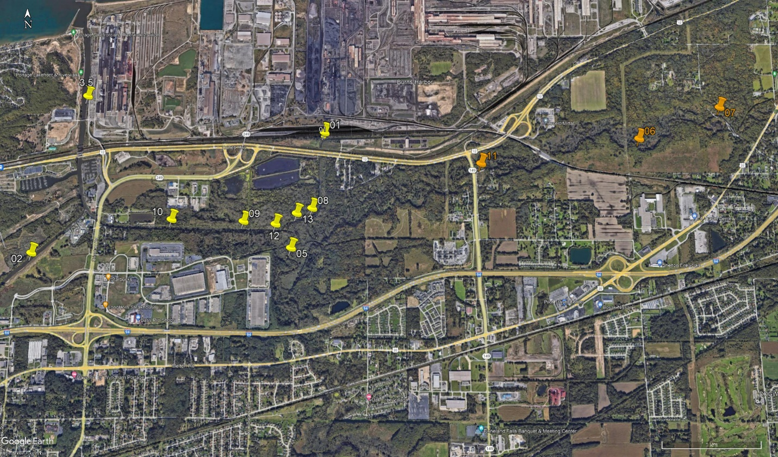

Figure 2. Test Organisms - Photos by Doug Hardesty – USGS

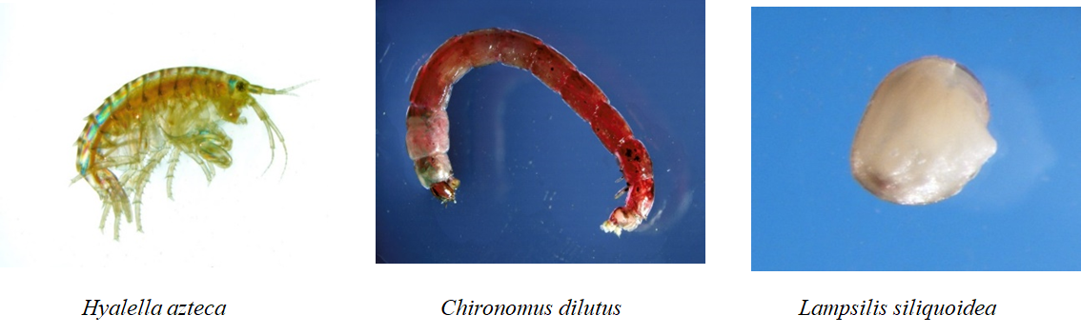
Figure 3. Sum of probable effect concentration quotients (PECQ, normalized to 1% TOC) for the four classes of compounds for Little Calumet sediments. Abbreviations are to Lake Michigan (to LKM), East Branch Little Calumet River (EBLCR), Samuelson Ditch (SD), East Branch Little Calumet River Reference Sites (REF), Salt Creek (SCK), Little Calumet River (LCR).
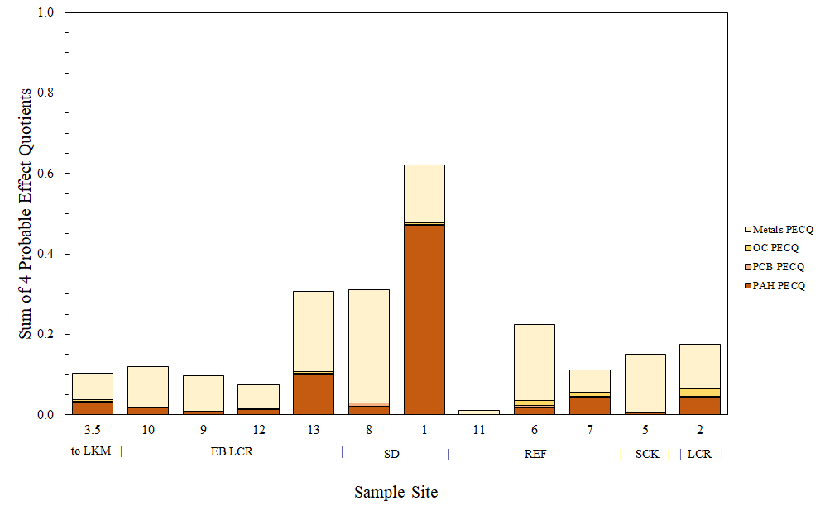
Figure 4. Survival of the three test organisms exposed to sediments from the Little Calumet River. An * designates a significant reduction compared to the reference site. The horizontal line designates the control survival test acceptability criteria of 80%.. Abbreviations are to Lake Michigan (to LKM), East Branch Little Calumet River (EBLCR), Samuelson Ditch (SD), East Branch Little Calumet River Reference Sites (REF), Salt Creek (SCK), Little Calumet River (LCR).
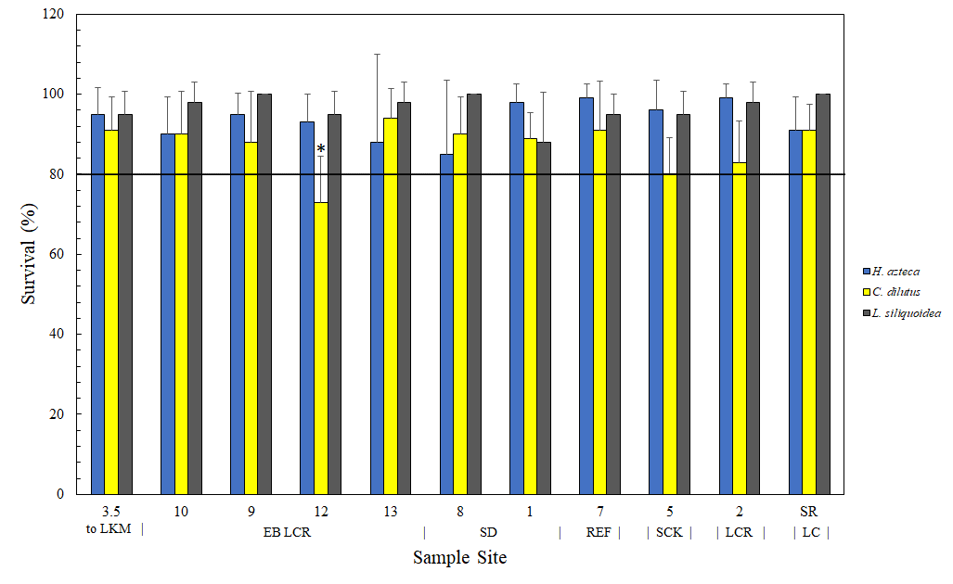

Figure 5. Biomass of the three test organisms exposed to sediments from the Little Calumet River. An * designates a significant reduction compared to the reference site. Abbreviations are to Lake Michigan (to LKM), East Branch Little Calumet River (EBLCR), Samuelson Ditch (SD), East Branch Little Calumet River Reference Sites (REF), Salt Creek (SCK), Little Calumet River (LCR).
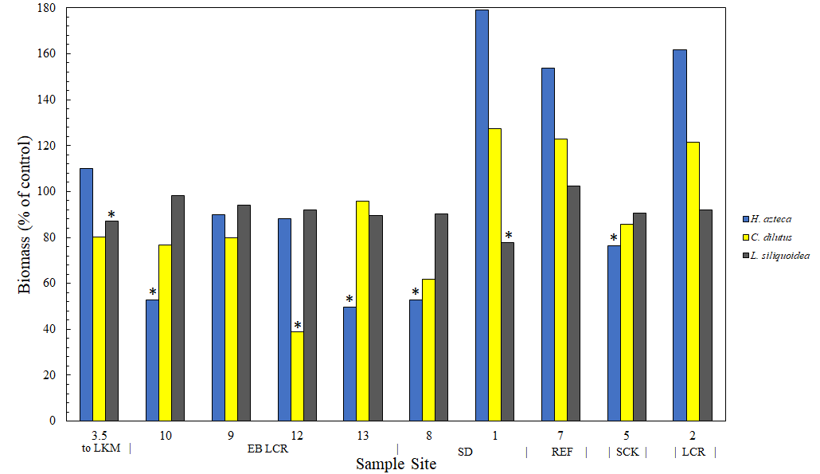
Table 1. Sediment and porewater chemistry data. Abbreviations are to Lake Michigan (to LKM), East Branch Little Calumet River (EBLCR), Samuelson Ditch (SD), East Branch Little Calumet River Reference Sites (REF), Salt Creek (SCK), Little Calumet River (LCR).

Location | Site | Probable Effects Concentration Quotient | SEM-AVS/foc | Unionized Porewater Ammonia (mg/L) | Interstitial Toxic Units¹
to LKM | 3.5 | 0.026 | -64.893 | 0.074 | 0.084
EBLCR | 10 | 0.030 | -53.674 | 0.51 | 0.108
EBLCR | 09 | 0.025 | 68.026 | 0.164 | 0.146
EBLCR | 12 | 0.019 | 12.714 | 0.066 | 0.181
EBLCR | 13 | 0.076 | 120.941 | 0.076 | 0.147
SD | 08 | 0.078 | 207.865 | 0.021 | 0.168
SD | 01 | 0.155 | 185.099 | 0.365 | 0.096
REF | 11 | 0.003 | 0.974 | 0.029 | 0.159
REF | 06 | 0.056 | 30.015 | 0.015 | 0.119
REF | 07 | 0.028 | -230.809 | 0.034 | 0.092
SCK | 05 | 0.038 | 20.259 | 0.007 | 0.108
LCR | 02 | 0.044 | 37.479 | 0.100 | 0.065

¹= sum of porewater metals (cadmium, copper, lead, nickel, silver, and zinc)

