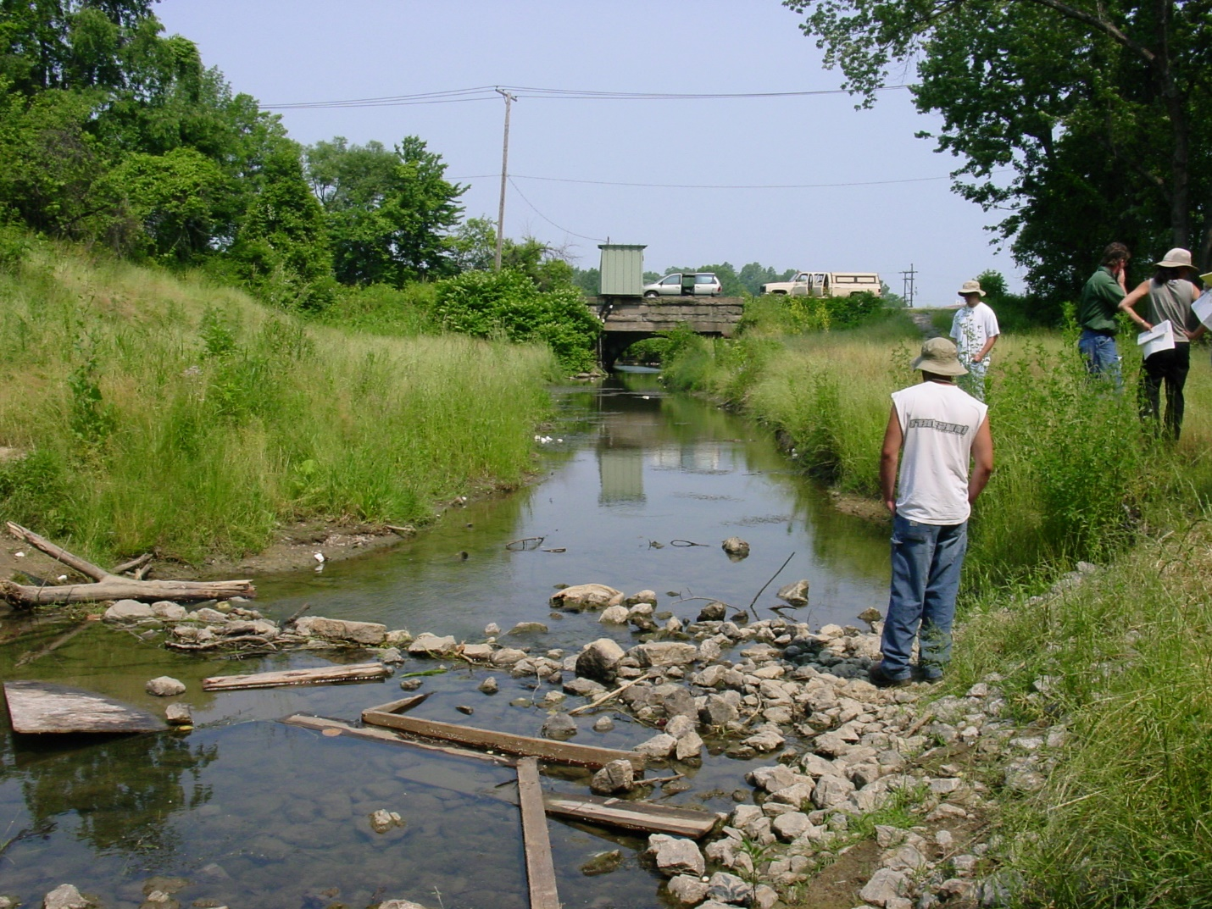
Fields Brook, Ashtabula, OH 6/21/2002(FWS)

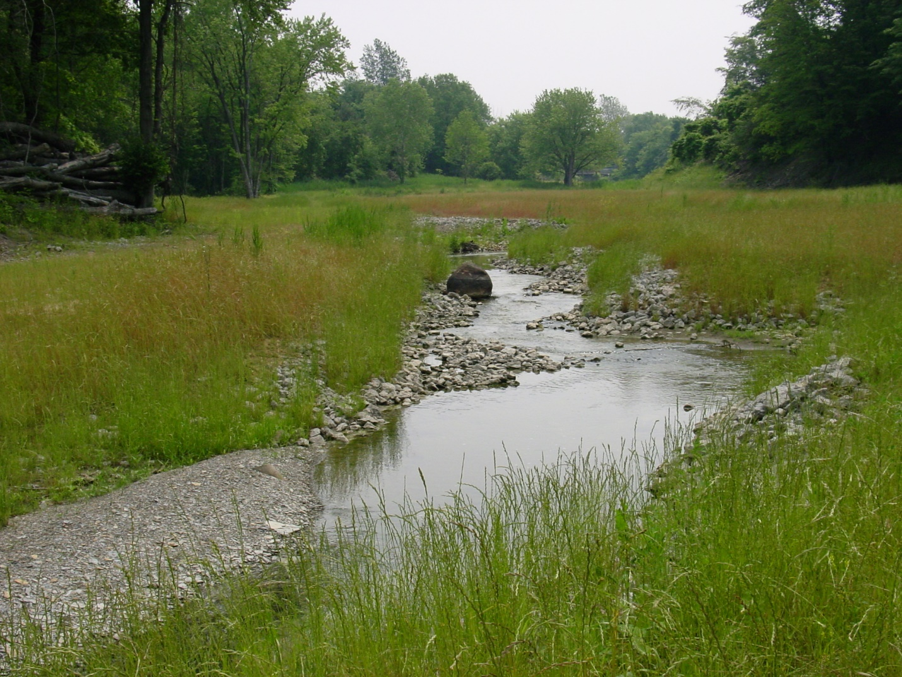
Fields Brook, Ashtabula, OH 6/21/2002 (FWS)

Fields Brook, Ashtabula, OH 6/21/2002 (FWS)

