SEPTEMBER 24, 2021

Texmo Diesel Spill and Fire

La Paz County, Arizona

FINAL Restoration Plan and Environmental Assessment Addendum

Prepared by:
Department of the Interior U.S. Fish and Wildlife Service

EXECUTIVE SUMMARY
This Final Restoration Plan and Environmental Assessment Addendum (RP/EAAd) was prepared by the Trustee to address natural resources, including ecological services, injured, lost or destroyed due to the spill of diesel, and subsequent fire, from the Texmo Oil Company Jobbers tanker truck accident into the Bill Williams River on the Bill Williams River National Wildlife Refuge (BWRNWR). The purpose of the restoration outlined and selected in this Final RP/EAAd is to compensate the public through restoration actions that would help return injured natural resources to baseline conditions and/or compensate for interim losses.

Restoration Plan and Envioronmental assessment Addendum
The Trustee prepared this Final RP/EAAd in accordance with the Oil Pollution Act (OPA) of 1990, 33 U.S.C. § 2701 et seq., and its implementing regulations, 15 C.F.R. Part 990. This Final RP/EAAd describes the likely injuries resulting from releases of diesel and the restoration projects intended to compensate the public for those injuries. The Trustee is the U.S. Department of the Interior (DOI), represented by the U.S. Fish and Wildlife Service (USFWS), acting on behalf of the Secretary of the Interior. The USFWS Southwest Regional Director is the Authorized Official for the DOI.

What was injured?
Natural resources and their supporting ecosystems that are or may have been affected by the spill include: endangered species and migratory birds, and delta marsh, desert wash, mixed riparian woodlands, open water aquatic, and upland desert habitats of BWRNWR.

What actions WERE SELECTED and evaluated in this Final RP/EAAd?
In the 2011 Texmo Restoration Plan and Environmental Assessment (RP/EA), the Trustee considered several restoration alternatives, including a No Action alternative, for the restoration of mixed riparian woodland and desert wash habitats. The Selected Alternatives in this Final RP/EAAd includes the following additional alternatives and restoration projects that will take place on BWRNWR and Havasu National Wildlife Refuge (HNWR):
Alternative D: Compensatory Restoration of Mixed Riparian Woodland and Desert Wash Habitats On-refuge but Off-site
- Project 1- Kohen Unit, BWRNWR: restoring at least 27 acres of mesquite bosque using invasive plant removal (Bermuda grass and salt cedar), irrigation (needing repair), protection (fencing), and nursery-grown seedlings (mesquite, palo verde, etc.).
Alternative E: Restoration of Comparable Habitats along the Bill Williams River Corridor or between Needles, California and Parker Dam, Arizona
- Project 2- Topock Marsh, HNWR: restoring at least 125 acres of desert riparian and upland/mesquite woodland using invasive plant removal (salt cedar and Sahara mustard), irrigation, protection (fencing and tree tubes), and nursery-grown seedlings (mesquite, cottonwood, willow, etc.).
Alternative H: Compensatory Restoration of Mixed Riparian Woodland and Desert Wash Habitats On-refuge but Off-site without Irrigation
- Project 3- Seed Collection, BWRNWR & HNWR: collecting, cataloging, and storing seeds from all native species.
- Project 4- Natural Regeneration Enhancement, BWRNWR: restoring at least 40 acres of desert wash, floodplain, and upland habitat, using groundwater monitoring, dead plant removal, channel modification (widening, clearing), and native seed dispersal.
Alternative I: Compensatory Restoration of Mixed Riparian Woodland and Desert Wash Habitats On-refuge but Off-site with Well Installation
- Project 5- Mesquite Bosque Restoration, BWRNWR: restoring at least 40 acres of desert riparian habitat using invasive plant removal (salt cedar), irrigation (requiring well installations), protection (fencing and tree tubes), and nursery-grown seedlings (mesquite, palo verde, etc.).

How are restoration projects being funded?
On September 12, 2007, Texmo Oil Jobbers, Inc. entered into a negotiated settlement and consent decree with the United States (represented by USFWS) to compensate the public for losses of natural resources and associated ecological services resulting from the spill of diesel and subsequent fire. USFWS received $1.2 million from the settlement. Settlement funds will be used to fund the selected restoration projects described in the Final RP/EAAd.

Table of Contents
EXECUTIVE SUMMARY ii
Restoration Plan and Envioronmental assessment Addendum ii
What was injured? ii
What actions WERE SELECTED and evaluated in this Final RP/EAAd? ii
How are restoration projects being funded? iii
Table of Contents iv
List of Maps/Figures v
List of Tables v
Abbreviations and Acronyms v
1.0 INTRODUCTION 6
1.1 Purpose and Need 6
1.2 Incident 6
1.3 Injured Natural Resources 6
1.4 Settlement 7
1.5 Restoration Plan and Environmental Assessment Addendum 7
1.6 Restoration Implementation Completed 8
2.0 ADDITIONAL RESTORATION ALTERNATIVES AND PROJECTS 9
2.1 Restoration Evaluation Criteria 9
2.2 Compliance with Laws, Regulations, and Policies 9
2.3 SELECTED Restoration Alternatives and Projects 10
2.3.1 Alternative D: Compensatory Restoration of Mixed Riparian Woodland and Desert Wash Habitats On-refuge but Off-site 11
2.3.1.1 Project 1: Kohen Unit 11
2.3.2 Alternative E: Restoration of Comparable Habitats Along the Bill Williams River Corridor or Between Needles, California and Parker Dam, Arizona 14
2.3.2.1 Project 2: Topock Marsh 14
2.3.3 Alternative H: Compensatory Restoration of Mixed Riparian Woodland and Desert Wash Habitats Along the Bill Williams River 23
2.3.3.1 Project 3: Seed Collection 23
2.3.3.2 Project 4: Natural Regeneration Enhancement 23
2.3.4 Alternative I: Compensatory Restoration of Mixed Riparian Woodland and Desert Wash Habitats On-refuge but Off-site with Well Installation 26
2.3.4.1 Project 5: Mesquite Bosque Restoration 26
2.4 Selected Alternatives 32
2.5 Alternatives Eliminated from Further Consideration 33
3.0 AFFECTED ENVIRONMENT 33
4.0 ENVIRONMENTAL CONSEQUENCES 34
4.1 Alternatives Previously Analyzed 34
4.2 Alternative Being Analyzed 34
5.0 BUDGET 35
6.0 PUBLIC PARTICIPATION 36
7.0 LIST OF PREPARERS 37
8.0 REFERENCES 38

List of Maps/Figures
Figure 1. BWRNWR, locations of the Texmo Oil Spill and Fire, and selected on-refuge projects 7
Figure 2. Project 1: Kohen Unit- Kohen South and Lower Kohen restoration units 12
Figure 3. HNWR and the selected off-refuge project restoration units 15
Figure 4. South Dike restoration unit 16
Figure 5. Mesquite Bays restoration unit 16
Figure 6. Bermuda Field restoration rnit 17
Figure 7. Mesquite Corridor restoration unit 18
Figure 8. Interior Road restoration unit 19
Figure 9. Natural Regeneration Enhancement areas 25
Figure 10. Mesquite Bosque pilot project plots and White Gate restoration unit 28
Figure 11. Alicia's Bend and Unnamed Bend 1 restoration units 29
Figure 12. Unnamed 2 & 3 restoration units 29

List of Tables
Table 1. Kohen Unit Restoration Timeline 13
Table 2. Topock Marsh Restoration Timeline 21
Table 2. Topock Marsh Restoration Timeline (cont.) 22
Table 3. Natural Regeneration Enhancement Timeline 26
Table 4. Mesquite Bosque Restoration Timeline 31
Table 5. Evaluation of Alternatives using selection criteria 32
Table 6. Environmental consequences of the addition of well installation 34
Table 7. Budget for restoration implementation, monitoring, and administration 35

Abbreviations and Acronyms
BWR Bill Williams River
BWRNWR Bill Williams River National Wildlife Refuge
DOI U.S. Department of the Interior
HNWR Havasu National Wildlife Refuge
NEPA National Environmental Policy Act
NRDAR Natural Resource Damage Assessment and Restoration
NWR National Wildlife Refuge
OPA Oil Pollution Act
RP/EAAd Restoration Plan and Environmental Assessment Addendum
RP/EA Restoration Plan and Environmental Assessment
USFWS United States Fish and Wildlife Service

1.0 INTRODUCTION
This Final Restoration Plan and Environmental Assessment Addendum (Final RP/EAAd) to the November 2011 “Final Restoration Plan and Environmental Assessment for Restoring Injuries to Wildlife and Fisheries Habitats from the Texmo Diesel Spill and Fire” (2011 Texmo RP/EA) details additional restoration projects that have been identified by the U.S. Fish and Wildlife Service (USFWS) as the natural resource trustee (Trustee) for addressing natural resources injuries resulting from the spill of diesel from a tanker truck and subsequent fire. In the 2011 Texmo RP/EA, the Trustee identified restoration project types to restore, enhance, or acquire approximately 10 to 64 acres of habitats in the Bill Williams River National Wildlife Refuge (BWRNWR) or Lower Colorado River area between Havasu National Wildlife Refuge (HNWR) and the Bill Williams River corridor (referred to as Alternative G, the Selected Alternative). This Final RP/EAAd briefly describes the incident, the injured natural resources, the terms of the Natural Resource Damage Assessment and Restoration (NRDAR) settlement, the restoration alternatives already evaluated in the 2011 Texmo RP/EA, and selected alternatives and projects not previously described or evaluated.

1.1 Purpose and Need
This Final RP/EAAd for the Texmo Diesel Spill and Fire is intended to inform the public about the natural resource and service injuries caused by the diesel spill and fire, and the selected restoration projects that could compensate for those injuries. This document is part of a natural resource damage assessment and restoration being performed pursuant to OPA (15 CFR § 990), by the USFWS, known as the Trustee.
This Final RP/EAAd includes several additional restoration projects to be undertaken in the vicinity of the spill site (Site) in the BWRNWR and associated habitats. For the purpose of restoring natural resources injured by the oil spill, the Trustee needs to implement restoration projects to restore those injured natural resources and services.

1.2 Incident
On July 28, 2006 a Texmo Oil Company Jobbers tanker truck accident resulted in a 7,600 - 7,800 gallon diesel spill into the Bill Williams River where it joins Lake Havasu on BWRNWR. The spilled diesel subsequently caught fire resulting in the loss or injury to 348 acres in woody riparian, open water, delta marsh, desert wash, and upland desert habitats and associated fish, wildlife, and other natural resources and the services they provide.

1.3 Injured Natural Resources
Five habitat types were injured by the spill and fire (Figure 1), including approximately 15 acres of open water, 235 acres of delta marsh, 60 acres of mixed riparian woodland, 20 acres of desert wash, and 18 acres of upland desert habitats. Vegetation in these habitats included cattail (Typha spp.), cottonwood (Populus fremontii), willow (Salix spp.), salt cedar (Tamarix spp.), mesquite (Prosopis spp.), various shrubs, cacti, palo verde (Parkinsonia spp.), creosote (Larrea tridentata), and bursage (Ambrosia spp.). Many species of birds, bats, insects, small mammals, and reptiles live in these habitats. Threatened and endangered species found at BWRNWR, and likely to have been affected, include southwestern willow flycatcher (Empidonax traillii extimus), Yuma Ridgway’s rail (Rallus longirostris yumanensis), razorback sucker (Xyrauchen texanus), bonytail (Gila elegans), and western yellow-billed cuckoo (Coccyzus americanus occidentalis). Many species of migratory birds use the various habitats for breeding, wintering, and migration.
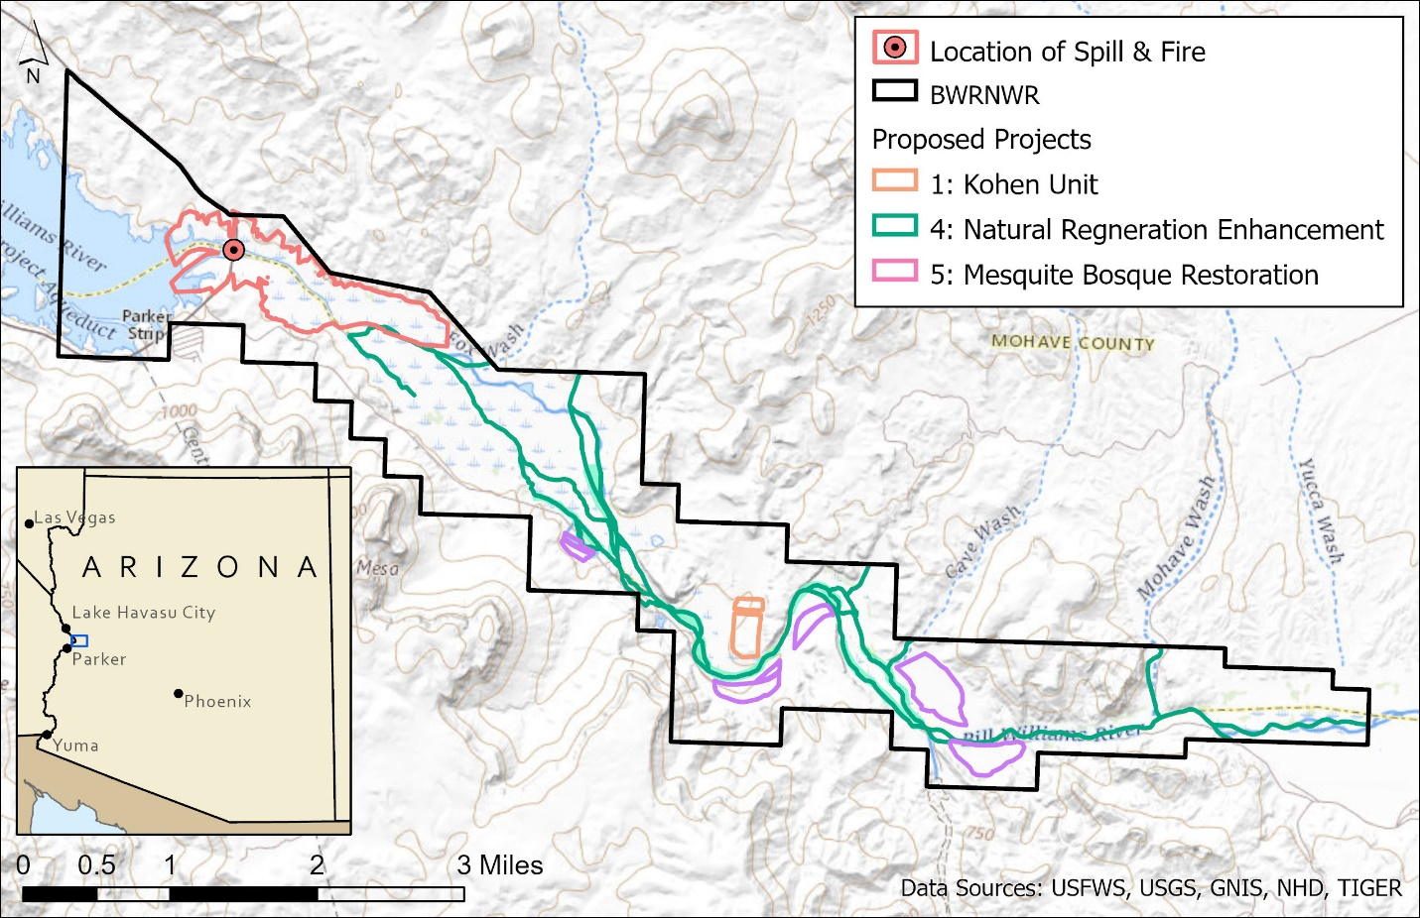
Figure 1. BWRNWR, locations of the Texmo Oil Spill and Fire, and selected on-refuge projects

1.4 Settlement
The terms of a Consent Decree entered on September 12, 2007, include $1.2 million in recovered damages to be used by the Trustee for restoration of injured natural resources as permitted under OPA.

1.5 Restoration Plan and Environmental Assessment Addendum
In compliance with the OPA regulations and the National Environmental Policy Act (NEPA), the Trustee evaluated the environmental consequences and restoration benefits of a range of restoration alternatives in the 2011 Texmo RP/EA. The restoration alternatives that were evaluated included no action, primary restoration of mixed riparian woodlands and desert washes on-site, acquisition of comparable habitats in the vicinity of BWRNWR, off-site compensatory restoration of mixed riparian woodland and desert wash habitats, restoration of comparable habitats off-site and off-refuge, and inventory research. In the 2011 Texmo RP/EA, the Trustee selected Alternative G (encompassing Alternatives B – F) as the Selected Alternative to accomplish restoration goals. The Draft 2011 Texmo RP/EA was reviewed by local state and federal agencies, and made available for public comment. Three comments were received from the government agencies, all of which were addressed. There were no significant adverse impacts expected from any restoration actions included in the Selected Alternative. This Final RP/EAAd supplements the 2011 Texmo RP/EA and incorporates by reference portions of the 2011 Texmo RP/EA for expediency and efficiency, as appropriate. The selected restoration actions associated with this Final RP/EAAd are in alignment with the goals of the 2011 Texmo RP/EA and are comparable with the Seected Alternative selected.

1.6 Restoration Implementation Completed
Emergency restoration actions pursuant to the OPA regulations (15 C.F.R. § 990.26) were conducted in December 2006, to prevent further soil erosion and the invasion of non-native plants into the riparian woodlands and desert washes impacted by the fire. Approximately 80 acres of the burned area was seeded with native grasses and forbs. The emergency restoration prevented further harm but did not fully compensate for the injuries.
Pursuant to Alternative C, the USFWS spent several years (2012-2015) trying to acquire 160 acres adjacent to BWRNWR, but that deal fell through. In 2018, the case manager reached out to several contacts in the watershed above BWRNWR to determine if landowners would be interested in a conservation easement of comparable cottonwood/willow habitat. There was no interest.
Pursuant to Alternative E of the 2011 Texmo R/EA, and subsequent to two fires, the Willow Fire and the Topock Fire on HNWR, the USFWS used the opportunity to cost-share cottonwood and willow restoration with Fire Management’s Burned Area Rehabilitation funds and allocated $225,000 of the settlement funds to HNWR. From 2016-2018, HNWR used some of the money to do site prep, salt cedar suppression, and cottonwood and willow planting. In 2016, HNWR spent $19,900 of the $225,000 hiring an intern to work on cottonwood and willow restoration. In 2019-2020, 40 acres were mowed, with subsequent salt cedar suppression efforts, and 16 acres were planted with native tree species (cottonwood, willow, and mesquite).

ADDITIONAL RESTORATION ALTERNATIVES AND PROJECTS
A balance of $1,044,030 of the recovered damages plus accrued interest remains available for additional restoration activities to restore injured natural resources on-site at BWRNWR.

2.1 Restoration Evaluation Criteria
The selected alternatives and projects in this Final RP/EAAd were evaluated using the same criteria as outlined in the 2011 RP/EA, including the six factors identified in the OPA regulations (15 C.F.R. § 990.54(a)):
- Cost to carry out the alternative;
- Extent to which each alternative is expected to meet the trustees’ goals and objectives in returning the injured natural resources and services to baseline and/or compensating for interim losses;
- Likelihood of success of each alternative;
- Extent to which each alternative will prevent future injury as a result of the incident, and avoid collateral injury as a result of implementing the alternative;
- Extent to which each alternative benefits more than one natural resource and/or service; and
- Effect of each alternative on public health and safety.
Additional factors considered by the Trustee include:
- Proximity to the affected site in locations where comparable biodiversity and ecological services can be secured or restored;
- Ecological benefits that can be measured for recovery of natural resources toward the pre-incident baseline;
- Long-term management and maintenance of the restoration site, including monitoring;
- Leveraging funds through partnerships;
- Regional landscape planning and local needs; and
- An implementation timeframe.
Project 1: Kohen Unit in this Final RP/EAAd falls within the general description and evaluation of Alternative D of the 2011 Texmo RP/EA, and Project 2: Topock Marsh falls within the general description and evaluation of Alternative E of the 2011 Texmo RP/EA. Therefore, no additional analysis of those selected projects against the restoration evaluation criteria is required. The 2011 RP/EA already determined that the Selected Alternative provides restoration activities that will meet the criteria detailed in 15 C.F.R. Part 990 (see 2011 Texmo RP/EA, Chapter 10).

2.2 Compliance with Laws, Regulations, and Policies
Development of this Final RP/EAAd requires consideration of a variety of legal authorities and their potential applicability to the Selected Alternatives. As part of the restoration planning process, the Trustee initiated steps to ensure compliance with applicable laws, regulations, and policies. Implementation of the Selected Alternatives remains subject to complying with all applicable laws and regulations, which for this Final RP/EAAd may include:
- National Environmental Policy Act
- Clean Water Act
- Endangered Species Act
- National Historic Preservation Act
Work performed as part of the Selected Alternatives would remain subject to meeting all permitting and other environmental compliance requirements to ensure the projects are implemented in accordance with applicable laws and regulations. The USFWS has determined that some actions to be performed are covered by the analysis completed in the 2011 Texmo RP and/or NEPA categorical exclusion found in 516 DM 8.5. A breakdown of project types in relation to the categorical exclusion is listed below.
- 516 DM 8.5 B.3: The construction of, or the addition of, small structures or improvements, including structures and improvements for the restoration of wetland, riparian, instream, or native habitats, which result in no or only minor changes in the use of the affected local area. The following are examples of activities that may be included.
(a) The installation of fences.
(b) The construction of small water control structures
(c) The planting of seeds or seedlings and other minor revegetation actions.
(d) The construction of small berms or dikes.
(e) The development of limited access for routine maintenance and management purposes.
The USFWS will follow its agency’s procedures to ensure NEPA compliance occurs and proper documentation is maintained.

2.3 SELECTED Restoration Alternatives and Projects
The selected restoration projects will address injuries to mixed riparian woodland and desert wash habitats off-site, both on- and off- refuge. As previously stated, Project 1 of Alternative D and Project 2 of Alternative E fit the alternatives described in the 2011 Texmo RP/EA. The other selected restoration projects fall within two new restoration alternatives, H and I, similar in actions and localities to that of Alternatives B, D and E, as further described below.
Riparian revegetation techniques often involve supplemental irrigation. Revegetation efforts on National Wildlife Refuges in arid regions are no exception. Anderson and Ohmart (1982) pioneered this technique along the lower Colorado River by installing a drip irrigation system to aid in the establishment of planted materials. Planting prescriptions were based on site capabilities, plant adaptations to soil texture, salinity and depth to water table, and wildlife habitat response models. This restoration effort remains a model of success of salt cedar thickets having been transformed back into native desert riparian wash and mixed woodland communities. The planting techniques for Projects 1, 2, and 5 outlined in this Final RP/EAAd rely on use of existing irrigation infrastructure, or the installation of new structures, including irrigation wells.

2.3.1 Alternative D: Compensatory Restoration of Mixed Riparian Woodland and Desert Wash Habitats On-refuge but Off-site
As a supplement to the 2011 Texmo RP/EA, and incorporated by reference, the restoration and enhancement of riparian habitats in burned areas (off-site) but on-refuge would include the expansion of the native bosque terrace plantings on the abandoned Kohen Ranch agricultural fields by a minimum of 20 acres. This area has an existing well and irrigation infrastructure. We would rehabilitate and expand the irrigation system and improve access for smaller heavy equipment. We would use a variety of methods to restore the habitat.

2.3.1.1 Project 1: Kohen Unit
Project Description
The overall goal of the Kohen Unit project is to restore over 20 acres to a mesquite-dominant bosque (Figure 2). In addition, BWRNWR has set both short-term and long-term restoration objectives for the Kohen project. The short-term objective of the project is to thin the vegetation to allow for the setup, operation, and maintenance of drip irrigation in addition to the planting of greenhouse-grown native trees and shrubs. Restoration success for the project will be measured using the following monitoring criteria:
- Relative density of Bermuda grass (Cynodon dactylon) following one season of treatment; and
- Percent survivorship of planted trees after the 1st and 2nd years, with survivorship over 50% indicating success.
The Kohen Unit project consists of two units: the Kohen South unit and the Lower Koehn unit. The 9-acre Kohen South restoration unit consists primarily of Bermuda grass with some mesquite. The first step towards achieving restoration success for this project involves treating and controlling approximately six acres of Bermuda grass. BWRNWR staff and the USFWS Invasive Species Strike Team (ISST) will be utilized for treatment of the Bermuda grass. Following successful treatment of the area through mowing, herbicide treatment, disking, and application of weed mats. Field crews will be utilized to set up drip irrigation and plant a mix of xeric species including mesquite, palo verde, acacia (Acacia spp.), ironwood (Olneya tesota), quailbush (Atriplex lentiformis), and wolfberry (Lycium spp.). Plantings will compete with, and eventually shade out, any resurgence of Bermuda grass that remains following the first season of treatment. Where appropriate (e.g., where soil salinity is high), additional seeding of patches with native grass, herbaceous species, and/or shrubs including quailbush, Mohave seablight (Suaeda nigra), saltgrass (Distichlis spicata), pickleweed (Salicornia spp.), and globe mallow (Sphaeralcea ambigua), will occur in order to optimize a mixed-mosaic habitat that supports high biodiversity. The long-term objective of the project is to control the Bermuda grass around the planted trees until the trees have reached a height where they are able to compete with, and eventually shade out, the Bermuda grass (approximately 3-4 feet tall).
The 18-acre Lower Kohen restoration unit consists primarily of mesquite, salt cedar, and quailbush, as well as patches of bare ground. Native upland habitat is well established in this area, therefore restoration efforts will be limited to small areas needing enhancement. Access to the unit will require creating an access road. Once access is established, examination of soil salinity and moisture will be used to determine appropriate actions for the unit. Possible actions include:
- Removal of salt cedar and stump treatment;
- Incorporation of dead vegetative debris into soil;
- Extension of irrigation from Kohen South project; and
- Planting and irrigation of mixed-xeric species, as outlined in the Kohen South project overview.
The short-term objective of the project is to remove the invasive salt cedar. The long-term objectives of the project are to prevent expansion of salt cedar into the area, and enhance the xeric habitat to support greater biodiversity, particularly for migratory birds.
Additional areas within the Kohen Unit will be restored, using the methods described above, as needed for continuity of habitat and as funding permits.

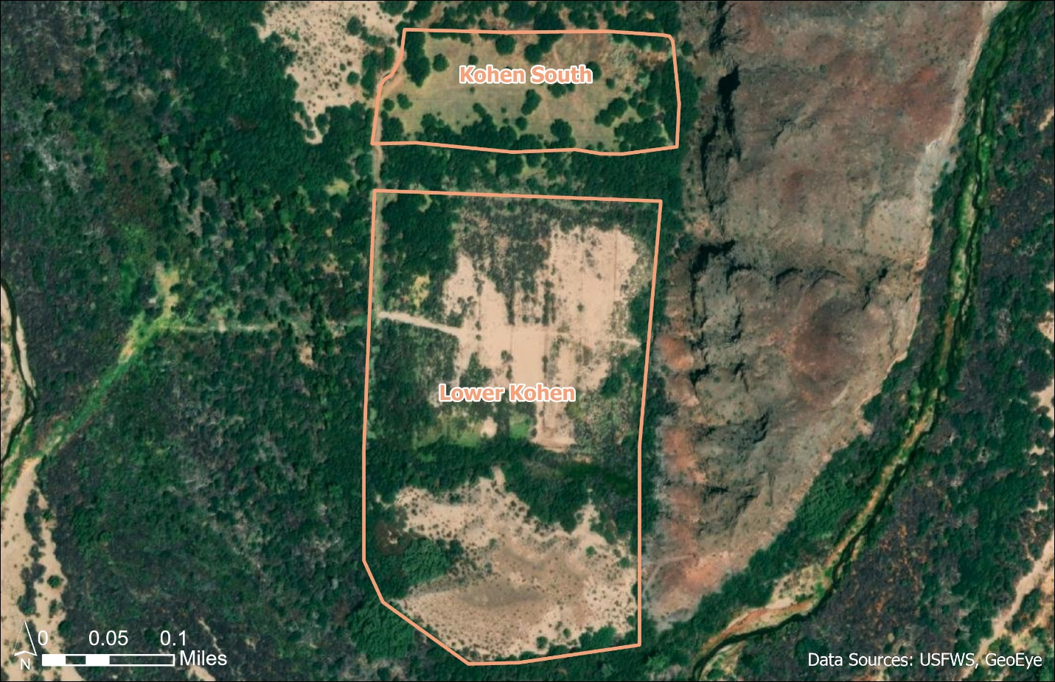
Figure 2. Project 1: Kohen Unit- Kohen South and Lower Kohen restoration units

Operations, Maintenance, and Monitoring
Analysis of herbicide use was analyzed in the 2011 Texmo RP/EA, Section 5.2 and Appendix A, and is incorporated by reference herein. In the event that herbicide is applied in this area, Fusilade DX will be used in order to control Bermudagrass for at least the first growing season. Herbicide will only be used if we are able to safely move heavy equipment into the area to mow the plant material down to a manageable level. If access cannot be obtained, manual control will be implemented, such as putting down weed mats. Best management practices related to Bermudagrass control and non-chemical weed control will be employed, including timing of application and/or treatments, as described in Cal-IPC (2020) and Cudney et al. (1970).
Javelina and rabbits have been identified as possibly problematic factors to the implementation of these projects. Wire fencing will be installed temporarily as needed to allow for tree establishment.
Monitoring survivorship of plantings will take place through the growing season, as well as assessing the treatment area for Bermuda grass regrowth. Growth and survivorship of plantings will be documented via use of remote sensing evaluations and/or photo points and monitoring plots at 6 months, 1 year, and 5 years following planting.
Table 1. Kohen Unit Restoration Timeline
DATES | UNIT | TASKS
May 2022 | South | Pre-treatment assessment
May – June  2022 - 2023 | South | Treat invasive plants & assess for regrowth
June - October  2022 - 2023 | South | Assess treatment area for regrowth, treat as needed
January  2024 - 2025 | South | Assess site for regrowth prior to irrigation setup and planting
 |  | Treat regrowth with herbicide/disking as appropriate
 |  | Begin drip irrigation array setup
February - March 2024 - 2025 | South | Complete irrigation array set up and planting
March - October  2024 - 2025 | South | Monitor survivorship of plantings through growing season
 |  | Assess treatment area for Bermuda grass regrowth
2022 - 2026 | Lower | Removal of salt-cedar, stump treatment, disking
 |  | Extension of irrigation system & planting
 |  | Monitor survivorship of plantings

2.3.2 Alternative E: Restoration of Comparable Habitats Along the Bill Williams River Corridor or Between Needles, California and Parker Dam, Arizona
As a supplement to the 2011 Texmo RP/EA, and incorporated by reference, Alternative E includes other suitable areas for restoration of Mixed Riparian Woodlands and Desert Washes on other Federal, state, or privately-owned lands between HNWR and the Bill Williams River (BWR) corridor as well as on HNWR, and on the BWR corridor. Restoration activities on other refuges or other government-owned lands could enhance biodiversity and ecosystem services of wildlife habitat and contribute to the protection of habitat solely for wildlife values. Restoration would likely include converting former agricultural fields to mesquite bosques or cottonwood-willow forests, perhaps including salt cedar control. Priority would be given to locations with similar habitat qualities or potential as those injured.

2.3.2.1 Project 2: Topock Marsh
Project Description
The overall goal of this project is to restore at least 125 acres of desert riparian and upland/mesquite woodland between the South Dike, Mesquite Bays, Bermuda Field, Mesquite Corridor, and Interior Road restoration units (see Figure 3). Restoration objectives include:
- Restore native vegetation that is more suitable for wildlife, watershed, and ecosystem function;
- Decrease establishment and spread of exotic species, principally salt cedar, in strategic locations to reduce threats to Threatened, Endangered, and Candidate species and their habitats, important watershed and wildlife resources, and to the future sustainability of wildlife habitat restoration efforts; and
- Continue to assess treatment-site conditions for restoration treatment alternatives that are cost-efficient and that have a greater chance of success.
Restoration efforts will focus on facilitated natural recovery of native species in strategic locations of high habitat value and restoration potential. Areas were partially identified for restoration efforts based on digital elevation and surface models derived from 2019 LIDAR data. These models were analyzed to determine low elevation locations with access to a shallow groundwater table and extract canopy height in forested areas around HNWR to determine existing pockets of native vegetation and potential seed sources. The general revegetation strategy will be to manage site conditions to restore native habitats and to facilitate natural recovery where feasible. Selected restoration treatments will be focused on sites primarily within the Topock Marsh management unit (Figure 3), including South Dike, Mesquite Bays, Bermuda Field, Mesquite Corridor, and Interior Road.
Herbicide control of exotic salt cedar will also be used at restoration sites at different intensities throughout the implementation of the plan. Pole planting and seeding will be implemented to augment natural recruitment. Irrigation will be employed using irrigation canals or portable pumps depending on the habitat type being restored (e.g. riparian vs. mesquite woodland), the depth to groundwater, soil salinity, and access to standing water sources for irrigation pumps. Project sites will be cleared with heavy equipment prior to planting. A skid steer with a masticating head will be used to remove/mulch existing salt cedar skeletons and other large debris before a site is leveled using a front-end loader, tractor, and/or a small dozer. A fire management team, i.e. the Lower Colorado River team, will be utilized when possible to conduct pile burns of large debris remaining after the use of a skid steer with a masticating head. Other debris will be scattered into piles around the edges of the project area to trap seeds and seedlings and encourage natural recruitment of native vegetation, and to increase habitat complexity for wildlife.
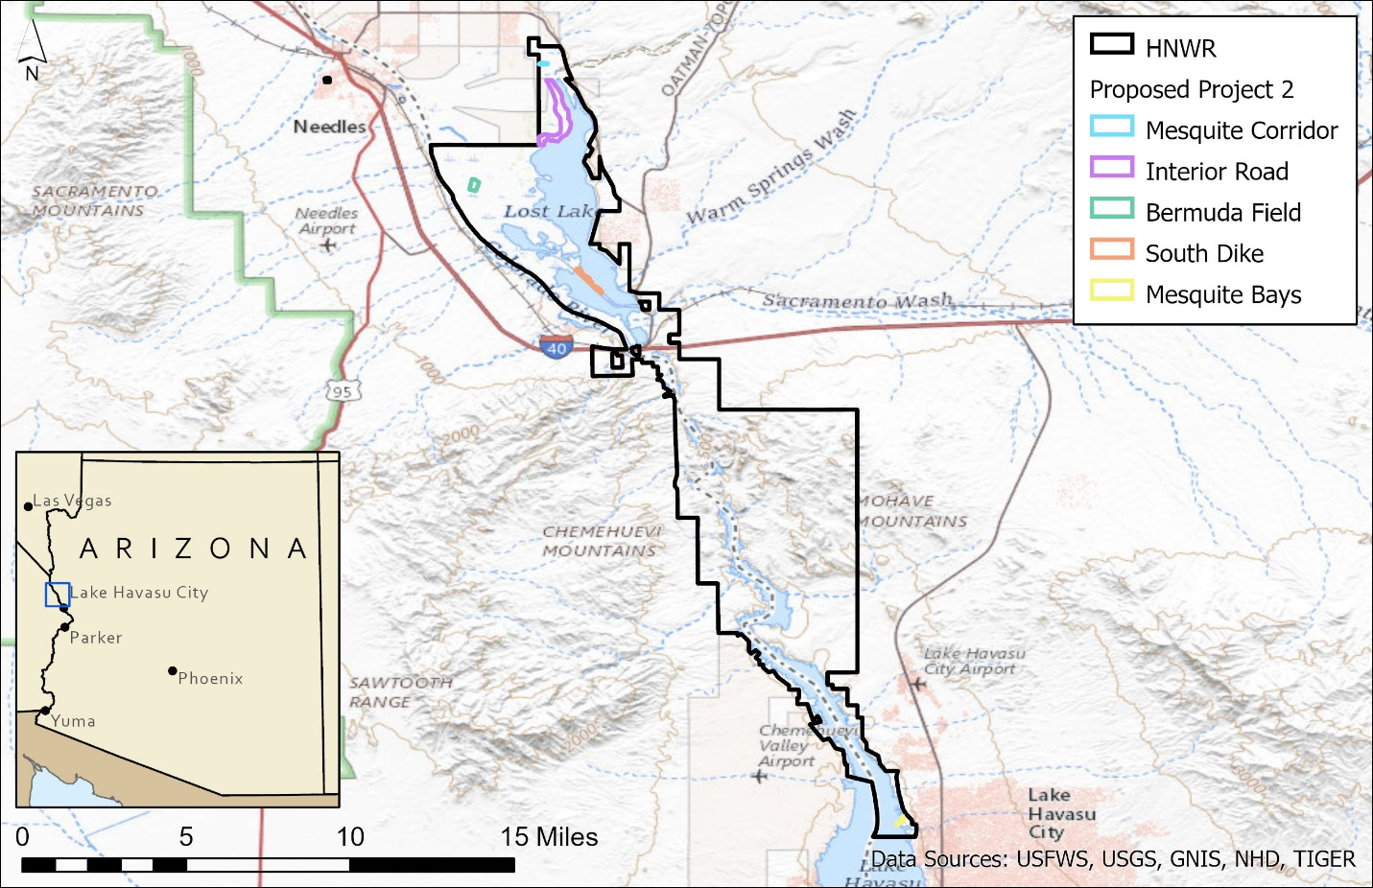
Figure 3. HNWR and the selected off-refuge project restoration units

The South Dike restoration unit (Figure 4) is approximately 56 acres of wildfire-impacted mesquite and desert riparian habitat. Intermittent flooding supports riparian vegetation in low-lying areas, and mesquite woodlands in higher more arid areas. Approximately 6 acres of riparian habitat and 10 acres of mesquite woodland have already been restored in this area. There is a shallow depth to groundwater and existing infrastructure from previous restoration efforts. This portion of the project would require nursery-grown trees, native seed, tree tubes, and protective cages.
The Mesquite Bays restoration unit (Figure 5) is approximately 6 acres of wildfire-impacted emergent wetland. Approximately 0.5 acres of riparian and 0.5 acres of mesquite/palo verde upland have already been restored in this area. There is a shallow depth to groundwater and existing infrastructure from previous restoration efforts. This portion of the project would require nursery-grown trees, native seed, tree tubes, and protective cages. Restoration efforts will focus on pole planting riparian tree species.
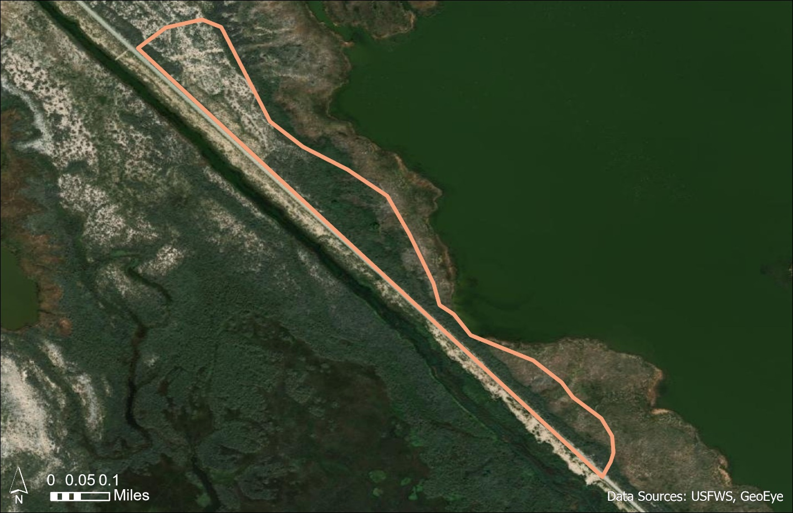
Figure 4. South Dike restoration unit
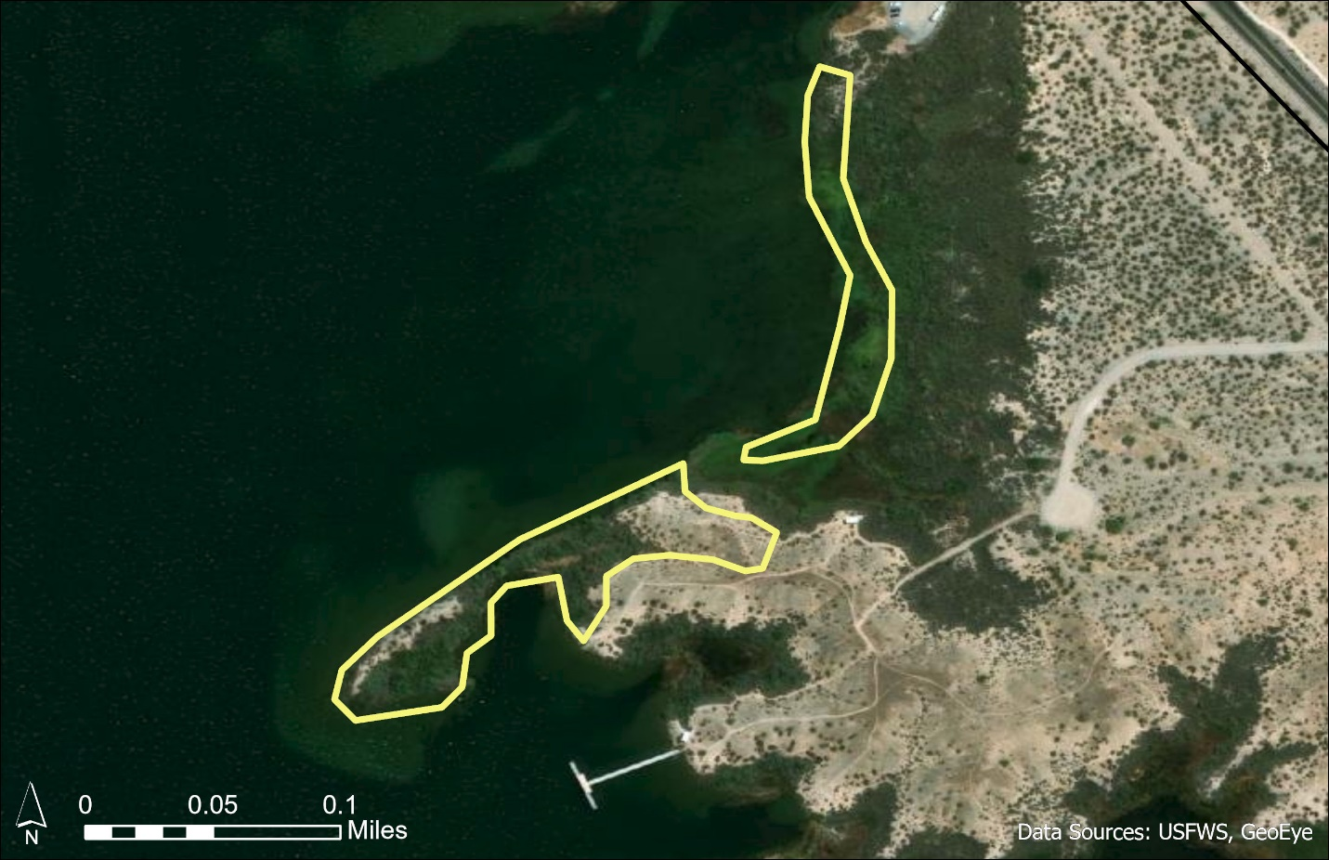
Figure 5. Mesquite Bays restoration unit
The Bermuda Field restoration unit (Figure 6) is a 70-acre former agricultural field primarily managed for Snow Goose (Anser caerulescens), that has been invaded by Sahara mustard (Brassica tournefortii). Initial steps in restoring this site would focus heavily on chemical and mechanical removal of invasive plants. The eastern 35 acres will be restored to a mesquite woodland, while the western half will be maintained as a small game unit. The restoration unit is proximal to a 28-acre riparian restoration area, and features natural riparian habitat, as well as existing irrigation infrastructure. This portion of the project would require nursery-grown trees, native seed, and tree tubes. Restoration efforts will focus on upland planting of honey mesquite (Prosopis glandulosa), screwbean mesquite (Prosopis pubescens), and native upland shrub species such as quail bush, four-wing saltbush (Atriplex canescens), and wolfberry.
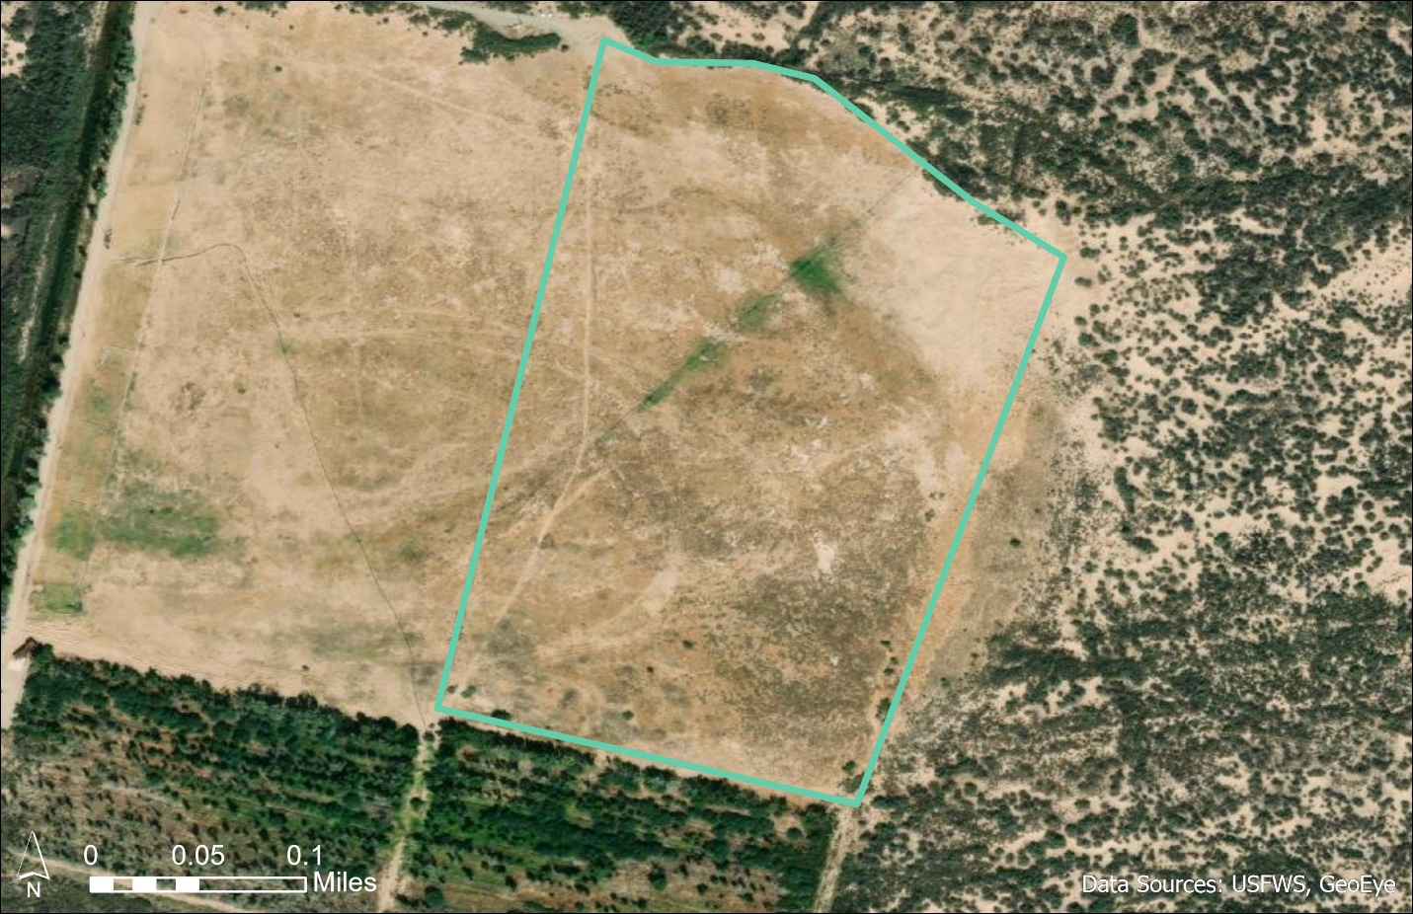
Figure 6. Bermuda Field restoration unit

The Mesquite Corridor restoration unit (Figure 7) is approximately 5 acres of wildfire-impacted, previously restored mesquite woodland. This area is managed for waterfowl and upland game hunting. There is proximity to passively restored mesquite savannah and mixed riparian and mesquite woodland, that this unit would integrate with, to create a continuous 40-acre native vegetation block. There is existing infrastructure from previous restoration efforts, and existing Atriplex spp. seed sources surrounding the area. This portion of the project would require nursery grown trees, native seed, tree tubes, and protective cages. Restoration efforts will focus on upland planting of honey mesquite, screwbean mesquite, quail bush, four-wing saltbush, and wolfberry.
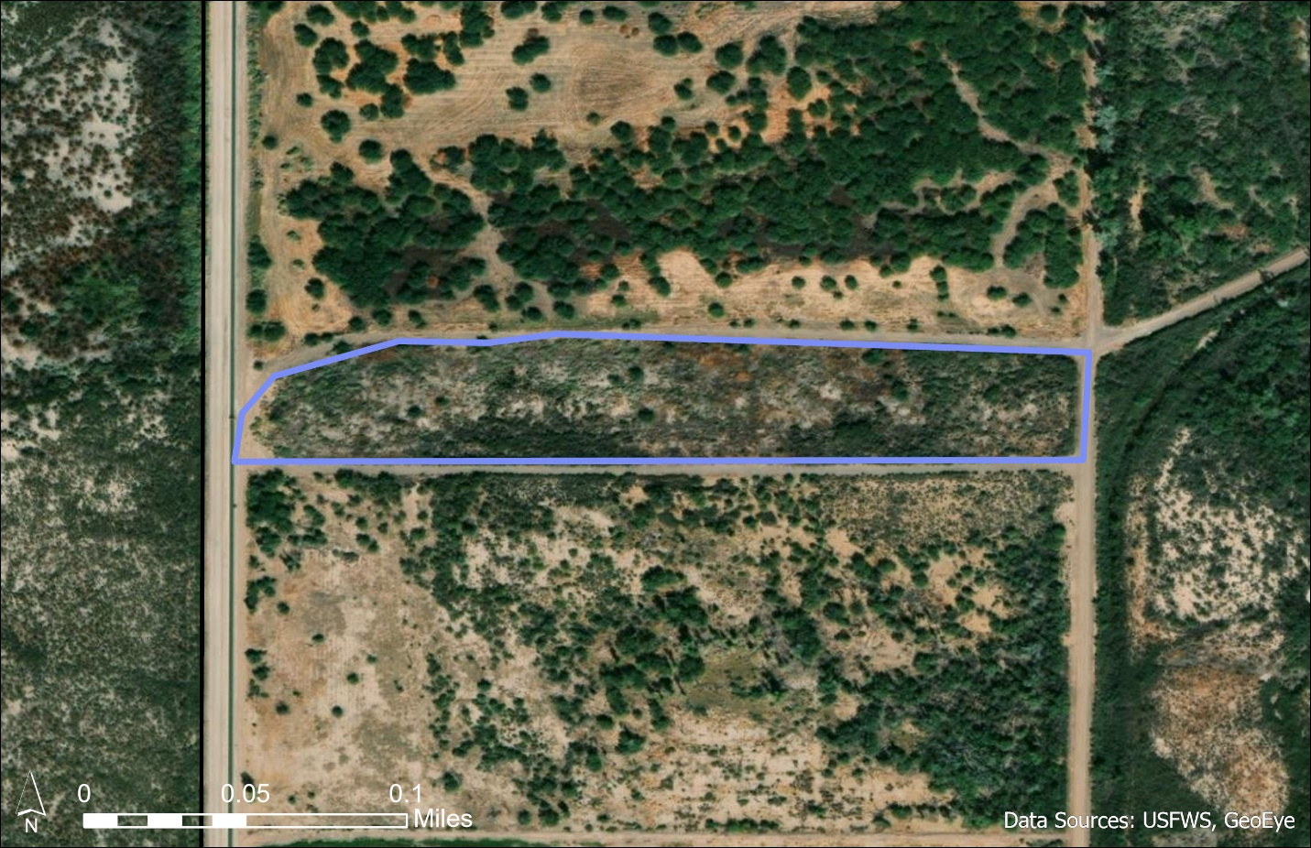
Figure 7. Mesquite Corridor restoration unit

The Interior Road restoration unit (Figure 8) is approximately 300 acres of wildfire-impacted riparian and mesquite woodland. Approximately 10 acres of riparian habitat has already been restored in this area, as mentioned in Section 1.6. There is a shallow depth to groundwater and existing infrastructure from previous restoration efforts, as well as proximity to existing restored areas. This portion of the project would require nursery-grown trees, native seed, tree tubes, and protective cages. Restoration efforts will focus on upland planting of honey mesquite, screwbean mesquite, Gooding’s willow (Salix gooddingii), and cottonwood by seedling and pole planting.

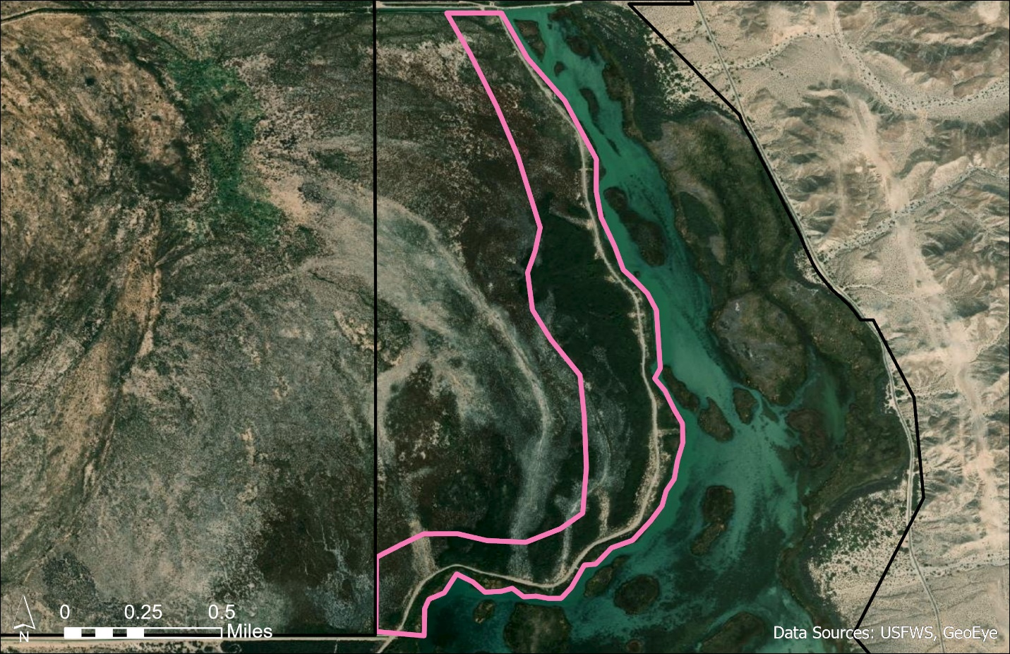
Figure 8. Interior Road restoration unit

Operations, Maintenance, and Monitoring
Salt cedar control will be conducted using herbicide treatments. Foliar application on resprouts and/or new germination of salt cedar will include triclopyr ester (Garlon IV Ultra or equivalent) at 20% concentration with vegetable oil adjuvant will be used in a low volume basal spray. This method is used when salt cedar are 3-6’ tall by applying herbicide to the lower 12-18” of the salt cedar sprout. Applications should be done in winter months when daytime high temperatures are forecasted below 80º Fahrenheit. Applications of triclopyr ester (Garlon IV) should cease once the temperature reaches 80º Fahrenheit due to the potential for volatilization. This application will be accomplished via backpack sprayer. Alternatively, other herbicides may be considered on a site-specific basis. New germination of salt cedar (up to 24” tall) can be hand pulled in moist soil conditions, but care must be taken to remove the taproot. A cut-stump application of 10% imazapyr (Habitat or equivalent) with a nonionic surfactant at a rate of 0.25 v/v (or 1 qt /100gal) or equivalent will be used for larger (greater than 6’) salt cedar encountered in restoration sites. Cut stump involves cutting down a live tree with a chainsaw and immediately applying herbicide to the remaining cut stump so that it can be translocated to the root system of the cut tree. Analysis of herbicide use was analyzed in the 2011 Texmo RP/EA, Section 5.2 and Appendix A, and is incorporated by reference herein.
Pole planting will include Fremont cottonwood, Coyote willow (Salix exigua), Goodding’s willow, honey mesquite, and screwbean mesquite. Cottonwood and willow establishment generally involves the cutting of short poles (< 1m) of various diameters (2- 10 cm) and either laying them laterally in moist soil conditions or inserting them vertically into moist soil during later winter season (February-early March). Once poles are cut, they must be soaked for 7-10 days before planting. Cottonwood establishment via seedling trees will occur in early March prior to rising soil and air temperatures seen in late spring. Cottonwood and willow also reproduce naturally by seed, through the precise timing of seed rain on moist mineral soil in spring. Honey mesquite seedlings will be planted during the late winter season, (February – early March). Natural regeneration from existing seed sources can occur through rainfall and can be enhanced with localized irrigation.
Seedlings have the potential to be consumed by a host of native wildlife. Mesquite species can generally be protected from herbivory through the first and second growing seasons via tree tubes. Cottonwood and willow species require more extensive protection from American beaver (Castor canadensis). These species require a 3-4’ tall metal cage around the stem to keep beaver from cutting down or browsing limbs from young trees. Both tree tubes and cages will be monitored and removed for potential negative impacts to growing trees as needed.
Monitoring survivorship of plantings will take place throughout the growing season, as well as assessing the restoration site for regrowth or invasion by exotic species, wildlife damage, and potential negative impacts on vegetation growth as a result of tree tubes and cages. Growth and survivorship of plantings will be documented on the ground via photo monitoring points and monitoring plots at 6 months, 1 year, 2 years, and 5 years following planting. An open-source remote sensing software, Climate Engine, that measures normalized difference of vegetation index (NDVI) to determine peak “greenness” during the growing season, will be used to quantitatively monitor the long-term progress and success of restoration sites.

Table 2. Topock Marsh Restoration Timeline
DATES | UNIT | TASKS
September - December  2021 | Mesquite Bays | Monitor restoration site for growth and survival
 |  | Invasive removal
 | Bermuda Field | Invasive removal and clear project area
January - March  2022 | Bermuda Field | Prepare irrigation and planting
 | Mesquite Bays | Monitor restoration site for growth and survival
 |  | Invasive removal
 | Mesquite Corridor | Prepare tree order for 2023 planting
 | Interior Road | Prepare tree order for 2023 planting
September - December  2022 | Mesquite Bays | Invasive monitoring/removal
 | Bermuda field | Monitor restoration site for growth and survival
 |  | Invasive removal
 | Mesquite Corridor | Invasive removal and clear project area
 | Interior Road | Invasive removal and clear project area
January - March  2023 | Mesquite Bays | Monitor restoration site for growth and survival
 |  | Invasive removal
 | Bermuda Field | Monitor restoration site for growth and survival
 |  | Invasive removal
 | Mesquite Corridor | Prepare irrigation and planting
 | Interior Road | Prepare irrigation and planting
 |  | Prepare tree order for 2024 additional planting
 | South Dike | Prepare tree order for 2024 planting
September - December  2023 | Mesquite Bays | Invasive monitoring/removal
 | Bermuda Field | Invasive monitoring/removal
 | Mesquite Corridor | Monitor restoration site for growth and survival
 |  | Invasive removal
 | Interior Road | Monitor restoration 2023 site for growth and survival
 |  | Invasive removal
 |  | Invasive removal and clear project area for 2024 acreage
 | South Dike | Invasive removal and clear project area
January - March  2024 | Bermuda Field | Monitor restoration site for growth and survival
 |  | Invasive removal
 | Mesquite Corridor | Monitor restoration site for growth and survival
 |  | Invasive removal
 | Interior Road | Monitor 2023 site for growth and survival
 |  | Invasive removal
 |  | Prepare irrigation and planting for 2025 acreage
 |  | Prepare tree order for 2025 planting
 | South Dike | Prepare irrigation and planting

Table 2. Topock Marsh Restoration Timeline (cont.)
DATES | UNIT | TASKS
September - December  2024 | Mesquite Bays | Invasive monitoring/removal
 | Bermuda Field | Invasive monitoring/removal
 | Mesquite Corridor | Invasive monitoring/removal
 | Interior Road | Monitor 2024 site for growth and survival
 |  | Invasive removal from 2023 and 2024 planting
 |  | Invasive removal and clear project area for 2025 planting
 | South Dike | Monitor restoration site for growth and survival
 |  | Invasive removal
January - March  2025 | Mesquite Corridor | Monitor restoration site for growth and survival
 |  | Invasive removal
 | Interior Road | Monitor 2023 & 2024 sites for growth and survival
 |  | Invasive removal
 |  | Prepare irrigation and planting on additional acreage.
 |  | Prepare tree order for 2026 acreage
 | South Dike | Monitor restoration site for growth and survival
 |  | Invasive removal
September - December  2025 | Mesquite Bays | Invasive monitoring/removal
 | Bermuda Field | Invasive monitoring/removal
 | Mesquite Corridor | Invasive monitoring/removal
 | Interior Road | Monitor 2025 site for growth and survival
Invasive removal from 2023 and 2024 planting
Invasive removal and clear project area for 2026 planting
 | South Dike | Invasive monitoring/removal
2026 - 2029 | All | Continued monitoring at restoration sites for growth and survival at 6 months, 1 year, 2 years, and 5 years following planting.
 |  | Invasive monitoring/removal
 | Interior Road | Continued expansion of restoration sites (up to 300 acres) as funding and personnel allow
As needed | All | Continued monitoring at restoration sites for growth and survival at 6 months, 1 year, 2 years, and 5 years following planting
 |  | Invasive monitoring/removal
 |  | Continued expansion of restoration sites (up to 300 acres) as funding and personnel allow

2.3.3 Alternative H: Compensatory Restoration of Mixed Riparian Woodland and Desert Wash Habitats Along the Bill Williams River
Comparable to Alternatives D and E of the 2011 Texmo RP/EA and incorporated by reference, Alternative H would allow for the collection of seeds to supplement restoration efforts, and the determination of suitable areas for enhancing the natural regeneration of mixed riparian woodlands and desert washes. Targets for enhancement include land where salt cedar could be removed, controlled, and then replanted with native woody riparian species like cottonwood, and willow, without the use of irrigation.

2.3.3.1 Project 3: Seed Collection
Project Description
Successful restoration projects requiring revegetation often necessitate use of species specific to the area being restored. It is well documented that there are phenological differences of similar species down the lower Colorado River corridor due to differing timing and magnitude of flooding and other streamflow events (Shafroth et al., 1998). For example, cottonwood trees at BWRNWR tend to leaf out and drop seed earlier in the spring than cottonwood trees at HNWR. For this reason, there is a need to begin collecting and storing seeds from local gene pools in the area to enhance the success of these and future restoration efforts.
Staff propose to collect, process, and store both riparian and desert upland species seeds, including honey mesquite, palo verde, catclaw acacia (Senegalia greggii), cottonwood, and willow. Seeds will be collected February through August, depending on seasonality.
To preserve the long-term viability of the seeds, a freezer unit that maintains constant temperatures is required. In addition, staff will purchase supplies to catalog and organize the seed bank (McComb & Lovestead, 1954; De Vitis et al., 2020).
The seed collection will be labelled, and a catalog maintained; noting the species and variety, the precise geographic location of the collection (including seed zone if known), the elevation, soil type, date of collection, and the signature of the collector (Stein et al., 1986).

2.3.3.2 Project 4: Natural Regeneration Enhancement
Project Description
The overall goal of the natural regeneration enhancement project is to restore desert wash, floodplain, and upland habitats, as addressed by the following two objectives:
- By 2025, mechanically clear a minimum of 10 acres of dead riparian vegetation, predominantly salt cedar for natural recruitment restoration; and
- By 2029, enhance a minimum of 500 meters of historic secondary channels to widen and promote channel change in the historic floodplain.
Enhancement areas have been preliminarily identified on 46 acres of river channel that are suitable for natural attenuation along a naturally braided desert riparian corridor. These areas are both congruent to the other selected projects in this Final RP/EAAd, and in other places along the river channel. Further natural regeneration enhancement projects will be identified by similar methods and take place at areas along the Bill Williams River that are accessible and provide continuity between already restored and/or existing desert wash and mesquite bosque habitat.
Preliminary identification methods for natural regeneration efforts were based on digital elevation and surface models derived from 2019 LIDAR data and are shown as the highlighted areas in Figure 9. These models were analyzed to extract canopy height in forested areas around BWRNWR, and ground-truthing confirmed that areas with canopy height greater than 15 meters tended to indicate locations of mature individual cottonwoods and willows. Digital elevation models were then used to confirm the presence of lower-elevation channels within the braided river system. This ensured that the selected project areas are near seed-bearing trees in areas that will be likely to support flowing water during flood events. BWRNWR staff is working with USGS to create a decision tool to help guide site selection, as well as determine appropriate species and restoration techniques based on site-specific hydrology, topography, current and past vegetative cover, and other relevant factors. Results of the tool will allow restoration efforts to be focused on those portions of the existing channel and former channels, shown as the lines in Figure 9, that have the highest probability for success.
For sites located in the active floodplain, enhancement activities will include first clearing debris and nuisance vegetation by use of mechanical, chemical, and manual methods. Large woody and herbaceous debris removal will require use of a 4WD tractor or skid steer masticator, due to the sandy substrate. Control of noxious weeds and grasses will require manual or chemical control. Next, riverbank contouring will be implemented where appropriate, using a tractor or skid steer with bucket attachments, to create gradual slopes and a suitable elevation gradient. This riverbank contouring will facilitate the recruitment of willow, cottonwood, and other native woody riparian species. Finally, broadcast seeding and/or pole planting will be conducted when conditions allow, following flood events during appropriate seasons. Seeds will be spread by hand to enhance natural vegetation establishment. In open areas which are far from seed-bearing trees, it may be necessary to purchase nursery-grown riparian trees from nearby vendors. The refuge will explore establishing lines of credit with local growers in order to have trees on-hand for last-minute flood events.
Similar enhancement activities will be completed for desert wash and upland habitats wherever possible along the Bill Williams River corridor within the BWRNWR boundaries. For these habitat types, management will be focused primarily on mechanically removing invasive species that may present barriers to the recruitment of native plant communities, as well as distributing the collected seed.

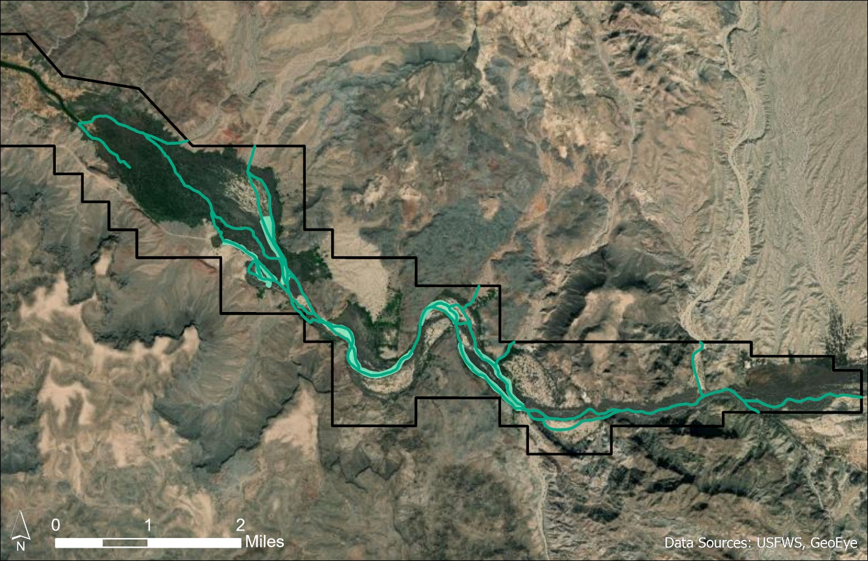
Figure 9. Natural Regeneration Enhancement areas

Operations, Maintenance, and Monitoring
BWRNWR works closely with the Army Corps of Engineers when planning Alamo Dam flow releases in order to optimize ecological benefits for downstream habitat. However, the most recent last-minute high-volume releases from the dam, starting in March 2020 in order to conduct emergency bulkhead maintenance, indicates that high flow events can sometimes be unpredictable and therefore difficult to plan restoration work around. Therefore, BWRNWR staff has elected to prepare land ahead of time in anticipation of high-flow events in order to optimize ecological benefits.
Due to the unpredictably from year-to-year of flood events, depending on seasonal rains and dam maintenance, invasive species on the cleared sites will need to be monitored and controlled regularly. The plan to minimize issues related to invasive species encroachment includes clearing smaller areas (2-3 acres) annually to start, with guidance from ISST. BWRNWR staff will monitor the project sites for presence/absence of invasive species, such as salt cedar and Bermuda grass. Once invasive species are detected in the project area, they will be treated immediately using herbicide or, where possible, removal by hand. Analysis of herbicide use was analyzed in the 2011 Texmo RP/EA, Section 5.2 and Appendix A, and is incorporated by reference herein.
BWRNWR staff will continue to monitor the sites on-the-ground in order to detect and treat invasive species and determine establishment success. Climate Engine -- an open-source remote sensing software that measures normalized difference of vegetation index (NDVI) to determine peak “greenness” during the growing season -- will be used to quantitatively monitor the long-term progress of the sites (https://ecos.fws.gov/ServCat/Reference/Profile/130987).
A key component of restoration success on BWRNWR, regardless of species or method, is depth-to-groundwater. A cottonwood seedling can establish root lengths up to 60 cm within the first 60 days of germination; roots can then grow 1-4 cm per day as floodwaters recede (Mahoney and Rood 1998). Therefore, groundwater telemetry readers will be installed to monitor groundwater not only during the dry season, but also throughout flow events in order to predict floodwater recession and whether seedlings will be able to successfully establish root systems.
Table 3. Natural Regeneration Enhancement Timeline
DATES | TASK
2022-2025 | Mechanically clear 10+ acres of dead riparian vegetation
2026-2029 | Enhance 500 meters of historic secondary channels to widen and promote channel change in the historic floodplain
Year-round after implementation | Monitor native vegetation recruitment
 | Remove invasive plants

2.3.4 Alternative I: Compensatory Restoration of Mixed Riparian Woodland and Desert Wash Habitats On-refuge but Off-site with Well Installation
Comparable to Alternatives B and D of the 2011 Texmo RP/EA, which are incorporated by reference, Alternative I would allow for the restoration and enhancement of riparian habitats that are off-site but on-refuge. This Alternative would require installation of an irrigation well, and installation of the irrigation infrastructure determined to be the most successful during the pilot project. A variety of methods would be used to restore the habitat.

2.3.4.1 Project 5: Mesquite Bosque Restoration
Project Description
The initial goal of this project is to restore a minimum of 10 acres using several restoration units, with a final goal of 30-40 acres, of salt cedar invaded, drought-impacted, desert riparian area to a drought-tolerant mesquite-dominant bosque. As an initial step in accomplishing this goal, BWRNWR staff is conducting a small-scale pilot project assessing the success of alternative methods of water delivery for honey mesquite and other upland-type plantings. An additional 30-40 acres of mesquite bosque restoration, consisting of similar activities as described below, may occur on-refuge if the initial area of interest is successfully restored, and subject to funding.
In addition to the initial goal, BWRNWR has set the following objectives for this project:
- The short-term objective is to achieve high percent survivorship of trees at 6 months, one year, and two years after initial planting;
- The long-term goal for the project is to successfully coordinate and establish pilot water delivery systems (deep pipe, buried perforated pipe, and Cocoon) to sustain plantings of greenhouse-grown honey mesquite plugs within target restoration areas.
A 4-acre pilot project plot (see Figure 10) was created per OPA (15 CFR § 990.54(c)), since additional information was needed to identify and evaluate the feasibility and likelihood of success of restoration alternatives requiring irrigation. The site itself is populated primarily by standing dead cottonwood and salt cedar. From November 2020 through February 2021, the entire project area was cleared and leveled using a front-end loader, tractor, and backhoe. Some debris was fed through a chipper and mulch was distributed over the project area to optimize soil moisture. A crew belonging to the Arizona Interagency Fire District, comprised primarily of USFWS personnel, conducted pile burns immediately preceding planting operations in January 2021. A backhoe was then used to incorporate the nutrients of available biochar into the soil of the project area. Other debris was scattered around the edges of the project area to trap and encourage natural recruitment of native vegetation. A total of 520 honey mesquite seedlings were planted in the pilot project area during late February and early March 2021. The area is divided into three study plots with different types of irrigation in an effort to determine the most effective form of irrigation for the conditions of the site, and characteristics of the habitat. The trees are spaced 10-15 feet apart in each of the study plots. The first plot, has deep pipe irrigation as described by Bainbridge (2007), consisting of drilled and capped PVC pipe, and provides irrigation to 160 trees. The second plot has buried perforated pipe irrigation, also described by Bainbridge (2007), consisting of 3” drainpipe, that supports approximately 20 trees. The third plot features Cocoon irrigation, manufactured by the Land Life Company, which supports 310 trees. An additional 30 trees were planted without any irrigation equipment and will serve as a control. Results of the pilot project will inform irrigation infrastructure and planting methods for other selected projects and future restoration efforts.
The White Gate restoration unit project is approximately 4 acres of drought-impacted desert riparian habitat (Figure 10). This site will require installation of an irrigation well, as well as irrigation infrastructure, allowing for expansion of restoration into adjacent land. Restoration efforts on this unit will be commensurate with that of the pilot project described above, in regards to site preparation involving both irrigation and planting nursery-grown, drought tolerant, honey mesquite.
The Alicia’s Bend restoration unit is approximately 30 acres of desert riparian area (Figure 11). This project area is in the center of BWRNWR, an area that experienced severe riparian vegetation die-off due to the encroachment of the tamarisk beetle (Diorhabda spp.) and drought. This site will require installation of an irrigation well on-site, as well as irrigation infrastructure. Restoration efforts on this unit will be commensurate with that of the successful pilot project(s) described above, and focus on planting drought-tolerant desert upland species, such as mesquite, ironwood, acacia, and wolfberry in order to ensure that the project area is resilient to future droughts. Additional activities to ensure project success include restricting access by recreational OHV and other off-road travel through the installation of fencing.
Unnamed mesquite restoration areas 1, 2, and 3 constitute approximately 140 acres of desert riparian habitat (Figures 11 & 12). These project areas also experienced severe riparian vegetation die-off due to the encroachment of the tamarisk beetle and drought. Further site analysis is needed to determine the feasibility and success of restoration efforts in these areas. They may require installation of an irrigation well, and irrigation infrastructure will be necessary, depending on access to existing wells and infrastructure and accessibility by roads. Restoration efforts on these areas will be commensurate with that of the successful pilot project(s) described above, and focus on planting drought-tolerant desert upland species, such as mesquite, ironwood, acacia, and wolfberry in order to ensure that the project area is resilient to future droughts. Additional activities to ensure project success, includes restricting access by recreational OHV and other off-road travel through the installation of fencing.

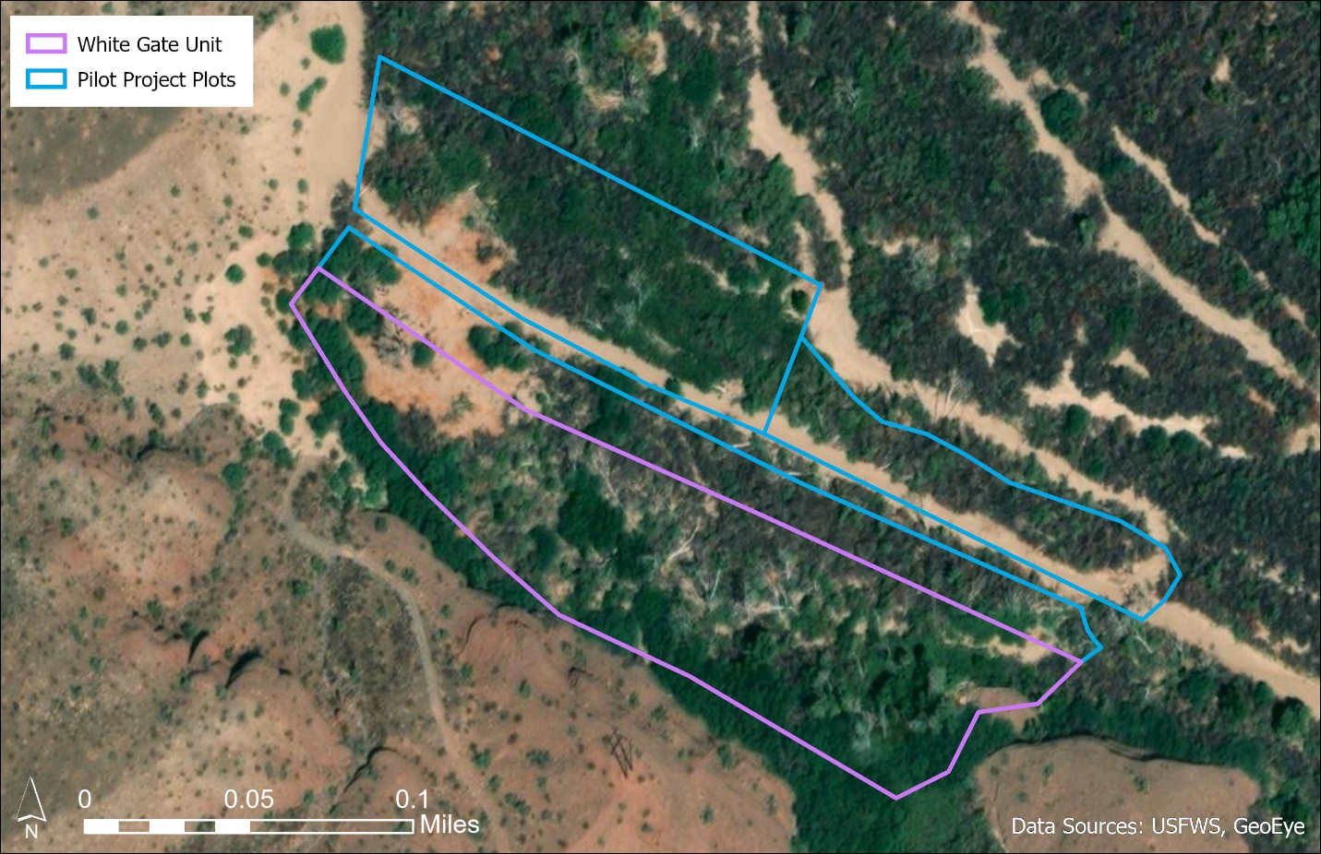
Figure 10. Mesquite Bosque pilot project plots and White Gate restoration unit
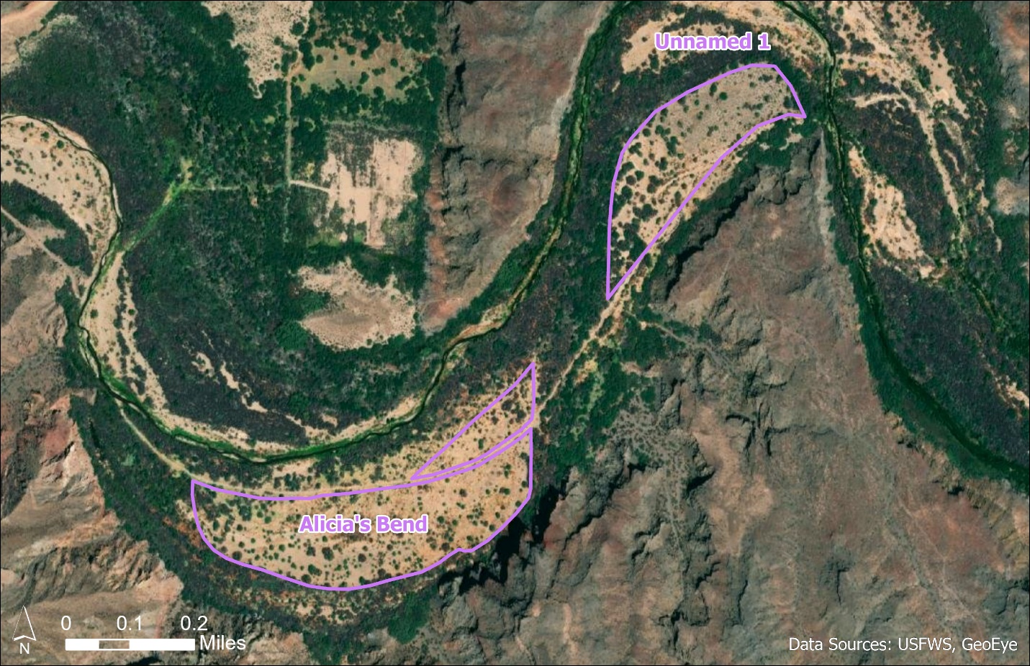
Figure 11. Alicia's Bend and Unnamed 1 restoration units
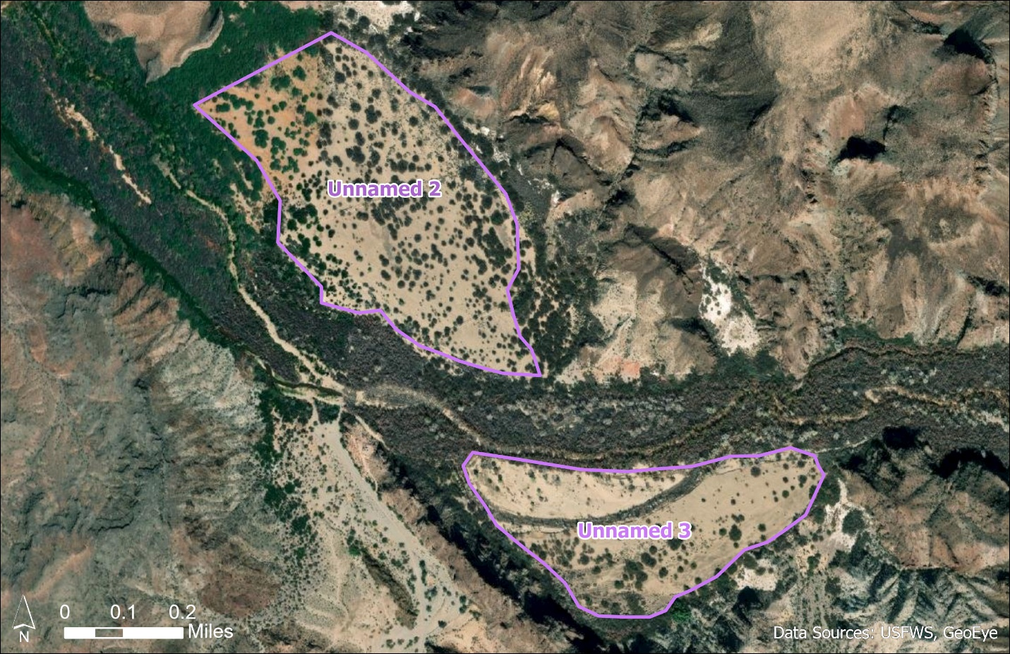
Figure 12. Unnamed 2 & 3 restoration units
Irrigation Well Installation
Well installation will require a minimum of five days for the site visit and installation of each well. The Bureau of Reclamation office in Provo, UT can provide a tracked drill rig specifically designed for installing wells in remote areas. The process will include drilling with a 14-inch auger system and installing a 6-inch diameter steel well casing with 20-feet of stainless screened interval. The total size of each irrigation well site, and the total depth drilled, will depend on site conditions and finalized at the site visit. Estimations indicate the need for 40 feet in depth and a footprint of no more than 100 square feet. Ground disturbance and the permanent footprint of the well pad will be minimized to the extent possible. The well sites will be accessible by existing roads whenever possible, though some clearing may be necessary for access and maintenance.
The Bill Williams River’s alluvium is highly permeable. Therefore, there is a high degree of connectivity between surface water and groundwater resources. Ground water dynamics and water table position in the floodplain are important factors in the establishment, restoration and maintenance of riparian habitat. The impact to the groundwater resource from dam operations is an important consideration in project success. Many of the irrigation wells within BWRNWR are located in remote and seasonally hard to reach locations, therefore, any new wells, and the existing wells, will be outfitted with telemetry equipment in order to access this groundwater data remotely in real-time. Having better access to this data will allow for monitoring of restoration projects and planning for future restoration projects.
Operations, Maintenance, and Monitoring
In western Arizona, mesquites must be planted in the cooler months, generally between December and March. This ensures that the seedlings can have time to establish roots and gradually acclimate to their first hot season, when daytime temperatures oftentimes exceed 110⁰F. Planting during the cooler months is critical to enhancing long-term survivorship of seedlings.
The HNWR has a pre-established relationship with Greenheart Nursery in Arroyo, CA, and has had great success with planting Greenheart mesquites, which are sourced from a Mojave Desert-specific gene pool. Orders will be placed as needed to meet timing of planting and personnel availability.
If invasive species, such as salt cedar, Sahara mustard, and Bermuda grass are detected in and around the project area, they will be treated via mechanical removal or, where appropriate, chemical treatment. Analysis of herbicide use was analyzed in the 2011 Texmo RP/EA, Section 5.2 and Appendix A, and is incorporated by reference herein.
In the event that Alamo Dam notifies partners of a last-minute high-flow release, BWRNWR personnel will pull and safely store as much of the project infrastructure (fencing, irrigation setups, heavy equipment, etc.) as possible. Study plot conditions (number of trees on site, tree condition, tree mortality, etc.) will be taken prior to and following the flow release.
Javelina and rabbits have been identified as possibly problematic to the implementation of these projects. To prevent javelina from digging up watering units, one-strand electric fence will be placed around the entire project area, not including the roadway, approximately 8" above the ground, or snout-height. To prevent rabbits from girdling trees, Tubex™ or Plantra™ tree shelters will be placed around each sapling.
The entire selected project area is located close to a public road. The electric wildlife fencing will also act as a barrier to potential vandalism. Trail cameras will be placed throughout the project areas at potential access sites. Proper signage will inform the public of these protective measures.

Table 4. Mesquite Bosque Restoration Timeline
DATES | UNIT | TASK
November 2020 - February 2021 | White Gate | Clear and prep project area
July 2020 -  December 2021 | White Gate | Prep irrigation materials
 |  | Coordinate tree delivery
February 2021 -  March 2021 | White Gate | Irrigation installation and planting
March 2021 -September 2023 | White Gate | Monitor project area and water as needed
November 2021 - February 2022 | Alicia’s Bend | Ground clearing, site prep
 |  | Invasive removal
March - April 2022 | Alicia’s Bend | Clear and prep additional project area(s)
 |  | Restoration planting
 |  | Wildlife proofing planted sites
Fall 2022 - 2029 | Alicia’s Bend | Clear and prep additional project area(s)
Spring 2023 - 2030 | Alicia’s Bend | Prep irrigation materials; coordinate tree delivery
 |  | Irrigation installation and planting
As needed | All | Invasive monitoring/removal at restoration sites
 |  | Removing old fencing/cages for growing trees
 |  | Monitor project area(s) and water

2.4 Selected Alternatives
The Selected Alternatives of this Final RP/EAAd include Alternatives D, E, H, and I as they all meet the restoration project selection criteria, and that of the restoration goals of the Trustee Council described in Section 2.1 and in the 2011 Texmo RP/EA.
Table 5. Evaluation of Alternatives using selection criteria
OPA Restoration Criteria | Alternative D  On-refuge, off-site, Kohen only | Alternative E  Off-refuge | Alternative H  On-refuge, off site | Alternative I  On-refuge, off site well installation
Cost to carry out | Costs to carry out these Alternatives fall within the amount received by settlement.
Consistency with Trustee Goals | These Alternatives are consistent with restoration goals to restore, rehabilitate, replace, or acquire the equivalent of the injured natural resources.
Likelihood of Success | These Alternatives are technically feasible, as supported and addressed by planning, design, implementation, operations and maintenance, and success of similar projects in BWRNWR and HNWR.
Avoidance of Further Injury | These Alternatives will not cause further long-term injury. However, short-term, minor, adverse impacts could occur in areas where restoration or enhancement activities are implemented or during natural resource management actions, such as invasive species treatments.
Extent of Benefits | Restoring environmentally sensitive habitat (mequite bosque) is anticipated to provide long-term benefits on the BWRNWR Kohen restoration unit to the wildlife that depend on them, including migratory birds. | Restoring environmentally sensitive habitat (mesquite/upland woodland and desert riparian) is anticipated to provide long-term benefits on the HNWR restoration units to the wildlife that depend on them, especially migratory birds and other riparian obligate species. | Restoring environmentally sensitive habitat (mixed riparian woodland and desert wash) is anticipated to provide long-term benefits on the BWRNWR to the wildlife that depend on them, including migratory birds. Seed collection will provide long-term restoration support. | Restoring environmentally sensitive habitat (mesquite/upland woodland and desert riparian) is anticipated to provide long-term benefits on the BWRNWR mesquite bosque restoration units to the wildlife that depend on them, including migratory birds.
Public Health and Safety | These Alternatives do not pose elevated public health and safety issues.
The Trustee has determined that Alternative H fits within USFWS’ NEPA categorical exclusion listed in Section 2.2.

2.5 Alternatives Eliminated from Further Consideration
A proposal from the United States Geological Survey for hydrologic mapping, analysis, and re-contouring of the Mohave Wash floodplain was considered and eliminated from further consideration due to costs and minimal usefulness to other restoration projects within BWRNWR.

3.0 AFFECTED ENVIRONMENT
The Trustee has determined that the affected environment of the Selected Alternatives is covered by the analysis of the physical characteristics, land use, biological and cultural resources, and socioeconomic conditions described in the 2011 Texmo RP/EA.

4.0 ENVIRONMENTAL CONSEQUENCES

4.1 Alternatives Previously Analyzed
The Trustee has determined that the environmental consequences of Alternatives D and E are within the range of consequences evaluated for the Selected Alternative in the 2011 Texmo RP/EA. These projects will consist of minor, short-term, ground disturbance. Short-term, negative environmental impacts may occur as a result of implementing the restoration, but the overall environmental impact, as measured by individual species, community development, and ecosystem services, is anticipated to be positive; Table 1 of the 2011 Texmo RP/EA provides a summary of environmental consequences for the Selected Alternatives, and is incorporated by reference herein.

4.2 Alternative Being Analyzed
The Trustee has determined that the environmental consequences of Alternative I require additional analysis. This alternative would restore the mixed riparian woodland and desert wash habitats on the refuge, but not in the primary areas affected by the spill and fire. This alternative is very similar to Alternatives B and D of the 2011 Texmo RP/EA, except that it would require well irrigation to establish native tree and shrub species. The goal of this alternative would be to turn low quality wildlife habitat into higher quality habitat and improve the habitat’s ecological function.
These projects will consist of minor, short-term, ground disturbance. Short-term, negative environmental impacts may occur as a result of implementing the restoration, but the overall long-term environmental impact, as measured by individual species, community development, and ecosystem services, is anticipated to be positive. Environmental consequences were analyzed for Alternatives B and D of the 2011 Texmo RP/EA, which covers the majority of actions selected by this project. Therefore, only the additional impacts of well installation are being included in this Section.
Table 6. Environmental consequences of the addition of well installation
RESOURCE | IMPACTS
Threatened & Endangered Species | No additional impacts.
Migratory Birds & Other Wildlife Species | Short-term (5-day), localized disturbance by heavy equipment, including noise, may impact local wildlife.
Water Resources | There are no permanent surface water bodies present within the selected project areas. Only short-term, localized disturbance to groundwater to install the wells, while irrigation water is being utilized may occur.
Ecosystem Services | No additional impacts.
Recreational Resources | Short-term (5-day), localized disturbance by heavy equipment, including noise and road access restriction, may impact recreation opportunities.
Cultural Resources | No additional impacts.
Socio-Economic Resources | No additional impacts.
Cumulative Impacts | No additional impacts.

5.0 BUDGET
The total budget for all selected projects is provided below.
Table 7. Budget for restoration implementation, monitoring, and administration
Project Name | Acres | Budget Item | NRDAR Settlement $
 |  |  | Per Item | Total
Administration | N/A | Project Management | $30,000 | $280,000
 |  | Biological Technician | $250,000
Project 1 –  Kohen Unit | 27 | Personnel (ISST crew) | $19,820 | $32,820
 |  | Trees and plants | $4,500
 |  | Materials, fuel, incidentals | $8,500
Project 2 –  Topock Marsh | 137 | Personnel- ACE crew and HNWR staff | $54,100 | $170,760
 |  | Trees, plants, and seeds (includes delivery) | $65,860
 |  | Materials, fuel, incidentals | $50,800
Project 2 –  Interior Road Restoration Unit | 40+ | Personnel- ACE crew | $65,300 | $141,140
 |  | Trees and plants | $37,100
 |  | Materials, fuel, incidentals | $38,740
Project 3 –  Seed Collection | N/A | Freezer & supplies | $1,500 | $1,500
Project 4 –  Natural Regeneration Enhancement | 40+ | Personnel | $12,500 | $34,000
 |  | Trees and plants | $17,000
 |  | Materials, fuel, incidentals | $4,500
Project 5 –  Mesquite Bosque Restoration | 80+ | Personnel- ACE crew and BWRNWR staff | $47,600 | $257,300
 |  | Irrigation well (installation and materials) | $52,000
 |  | Trees (includes delivery) | $45,300
 |  | Water monitoring system | $91,900
 |  | Materials, fuel, and incidentals | $20,500
Equipment | N/A | Tractor, water trailer, planter, bobcat, auger (includes maintenance) | $76,600 | $76,600
TOTAL |  |  |  | $994,120

6.0 PUBLIC PARTICIPATION
Public participation and review are integral parts of the restoration planning process and are specifically required in the OPA NRDAR regulations (15 C.F.R. § 990.55(c)). In addition, NEPA and its implementing regulations require that federal agencies fully consider the environmental impacts of their proposed decisions and that such information is made available to the public.
The Draft RP/EAAd was available for public comment and review for 30 days from the date of publication (July 21, 2021). An electronic version of the drafted document was posted on the DOI’s Restoration Program website (https://www.doi.gov/restoration/news/), and on the Arizona Ecological Services Field Office site (https://www.fws.gov/southwest/es/arizona/). An email and mail address for the Arizona Ecological Services Field Office were included in the Draft RP/EAAd as channels for the public to submit comments or input.
No public comments were received from the public, and no substantive changes have been made to this document since the Draft RP/EAAd was made available for public review. The Trustee may amend the Final RP/EAAd if significant changes are made to the type, scope, or impact of the projects. In the event of a significant modification to the Final RP/EAAd the Trustee would provide the public with an opportunity to comment on changes.
The Trustee has maintained records documenting the NRDAR process. These records are available on the Natural Resource Damage Assessment and Restoration Program Case Document Library (https://www.cerc.usgs.gov/orda_docs/ CaseDetails?ID=981 ).

7.0 LIST OF PREPARERS
This Final RP/EAAd was prepared by representatives of the natural resource trustee agency listed below, in consultation with other partnering agencies and stakeholders, and with the assistance of the DOI Restoration Support Unit.
John Bourne, Wildlife Biologist, Havasu NWR, U.S. Fish and Wildlife Service
Jeff Howland, Project Leader, Lake Havasu NWR Complex, U.S. Fish and Wildlife Service
John Isanhart, Restoration Ecologist, Restoration Support Unit, DOI-Office of Restoration and Damage Assessment
Sherry Kircher, DOI Regions 6 & 8 NRDAR Coordinator, U.S. Fish and Wildlife Service
Becky MacEwen, Environmental Specialist, Restoration Support Unit, DOI-Office of Restoration and Damage Assessment
Kevin Russell, Ph.D., Fish and Wildlife Biologist, Arizona Ecological Services Field Office, U.S. Fish and Wildlife Service
Ethan Seavey, Wildlife Biologist, Bill Williams River NWR, U.S. Fish and Wildlife Service

8.0 REFERENCES
Bainbridge, Dr. David. 2007. A Guide for Desert and Dryland Restoration. Island Press. 416 p.
Cal-IPC. 2020. Best Management Practices for Non-Chemical Weed Control. Report to California Department of Pesticide Regulation under grant number 18-PML-G002. 291 pp.
Cudney, D.W., Elmore, E.L., and Bell, C.E. 1970. Bermudagrass. University of California Cooperative Extension. 4 pp.
De Vitis, M., Hay, F.R., Dickie, J.B., Trivedi, C., Choi, J. and Fiegener, R. 2020. Seed storage: maintaining seed viability and vigor for restoration use. Restor Ecol, 28: S249-S255.
Mahoney, J. M. and S. B. Rood. 1998. Streamflow Requirements for Cottonwood Seedling Recruitment – An Integrative Model. Wetlands 18(4): 634-645.
McComb, A. L. and H. S. Lovestead. 1954. Viability of cottonwood seeds in relation to storage temperatures and humidities. USDA Forest Service Tree Planters Notes 17:9 -11.
Ohmart, R. D., Anderson, B. W., and W. C. Hunter. 1988. The ecology of the lower Colorado River from Davis dam to the Mexico-United States international boundary: a community profile. U.S.D.I.-U.S. Fish and Wildlife Service Biological Report 85(7.19). 296 pp.
Shafroth, P.B., G.T. Auble, J.C. Stromberg, and D.T. Patten. 1998. Establishment of woody riparian vegetation in relation to annual patterns of streamflow, Bill Williams River, Arizona. Wetlands 18(4): 577-590.
Stein, W.I., R. Danielson, N. Shaw, S. Wolff, & D. Gerdes. 1986. Users Guide for Seeds of Western Trees and Shrubs. Forest Service, U.S. Department of Agriculture, Pacific Northwest Research Station. PNW-193. 45p.
Texmo Diesel Spill and Fire NRDAR Trustee. 2011. Texmo Final Restoration Plan and Environmental Assessment. Prepared by the U.S. Fish and Wildlife Service. 64p

The CEQ NEPA regulations state the following regarding “incorporation by reference”: Agencies shall incorporate material into an environmental impact statement by reference when the effect will be to cut down on bulk without impeding agency and public review of the action. The incorporated material shall be cited in the statement and its content briefly described. No material may be incorporated by reference unless it is reasonably available for inspection by potentially interested persons within the time allowed for comment. Material based on proprietary data which is itself not available for review and comment shall not be incorporated by reference. 40 C.F.R. §1502.21.
The primary restoration goal identified in the 2011 Texmo RP/EA is to restore, enhance, or acquire approximately 10 to 64 acres of habitats in BWRNWR or the Lower Colorado River corridor between HNWR and BWRNWR.
Includes writing necessary reports, uploading documents to reporting systems, and closing out the case after completion of restoration implementation and monitoring.

