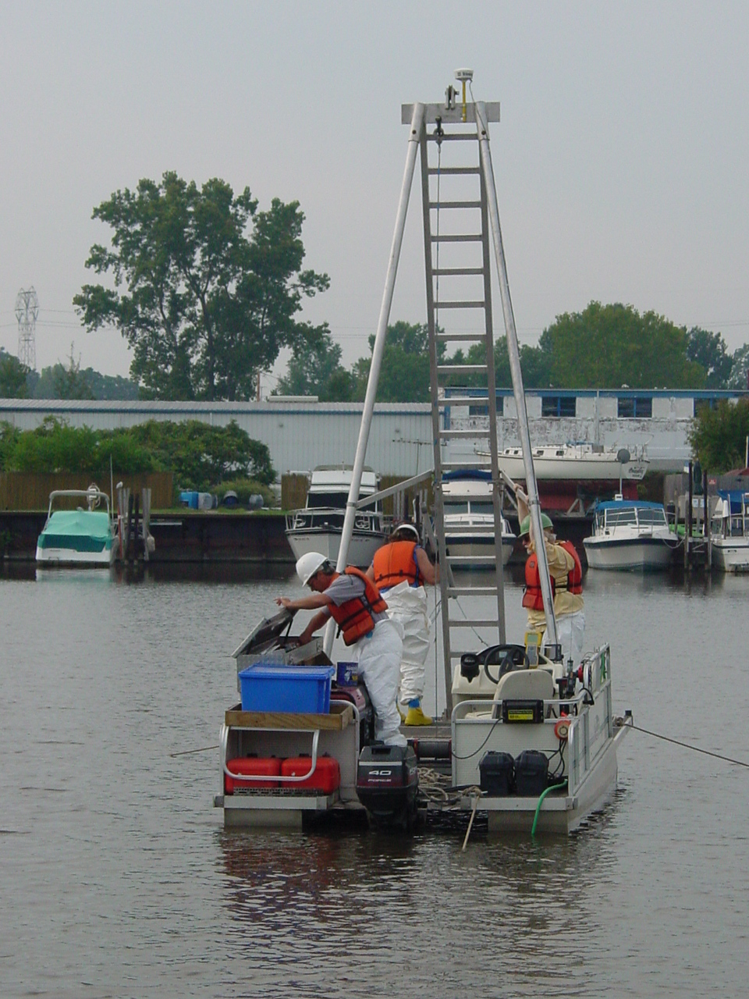
Ashtabula River Sediment Core Sampling 6/17/2003 (FWS)
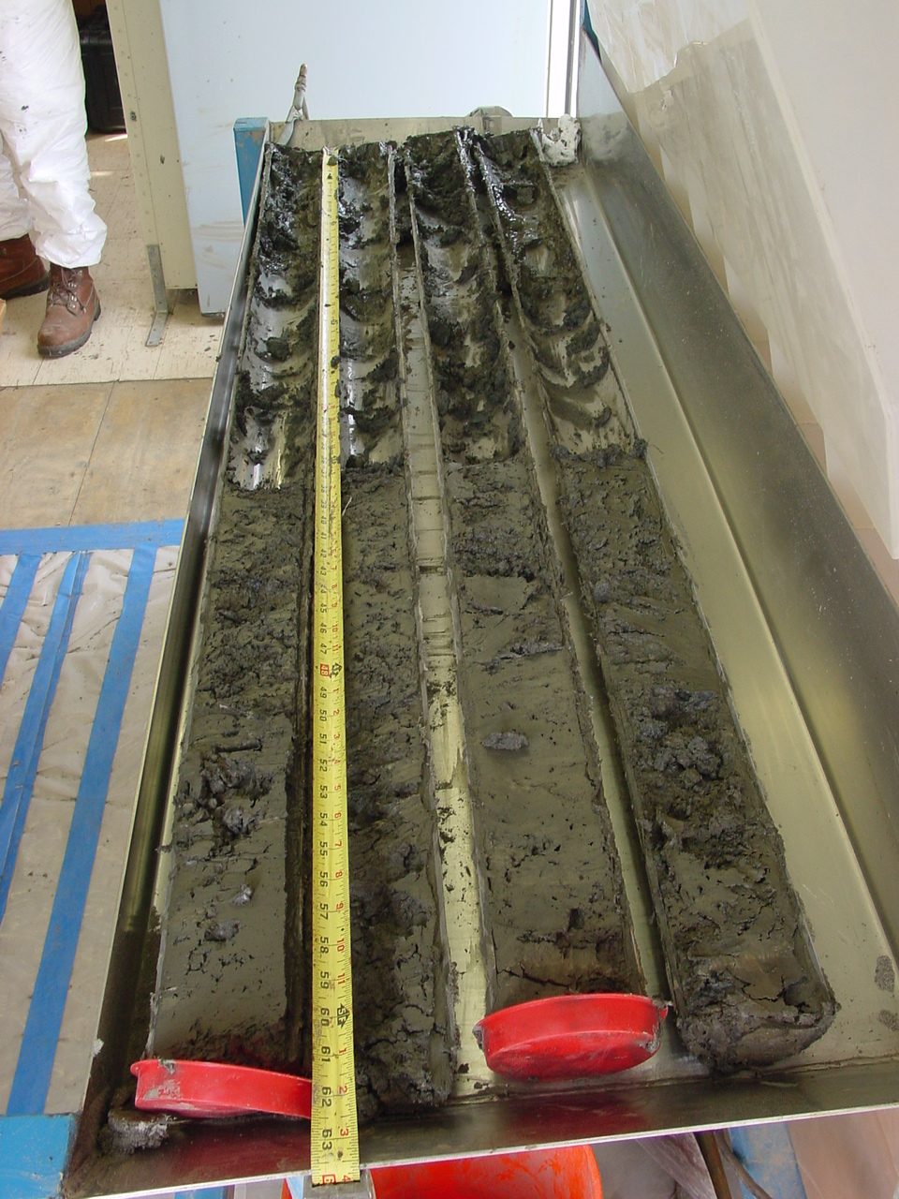
Ashtabula River Sediment Core Sampling – Sediment Cores 6/17/2003 (FWS)

